**LoadRunner**

Site- https://opensource-demo.orangehrmlive.com/

**(a)Load Test**

**1.Virtual user generator**

Opening virtual user generator, creating a script and a solution.

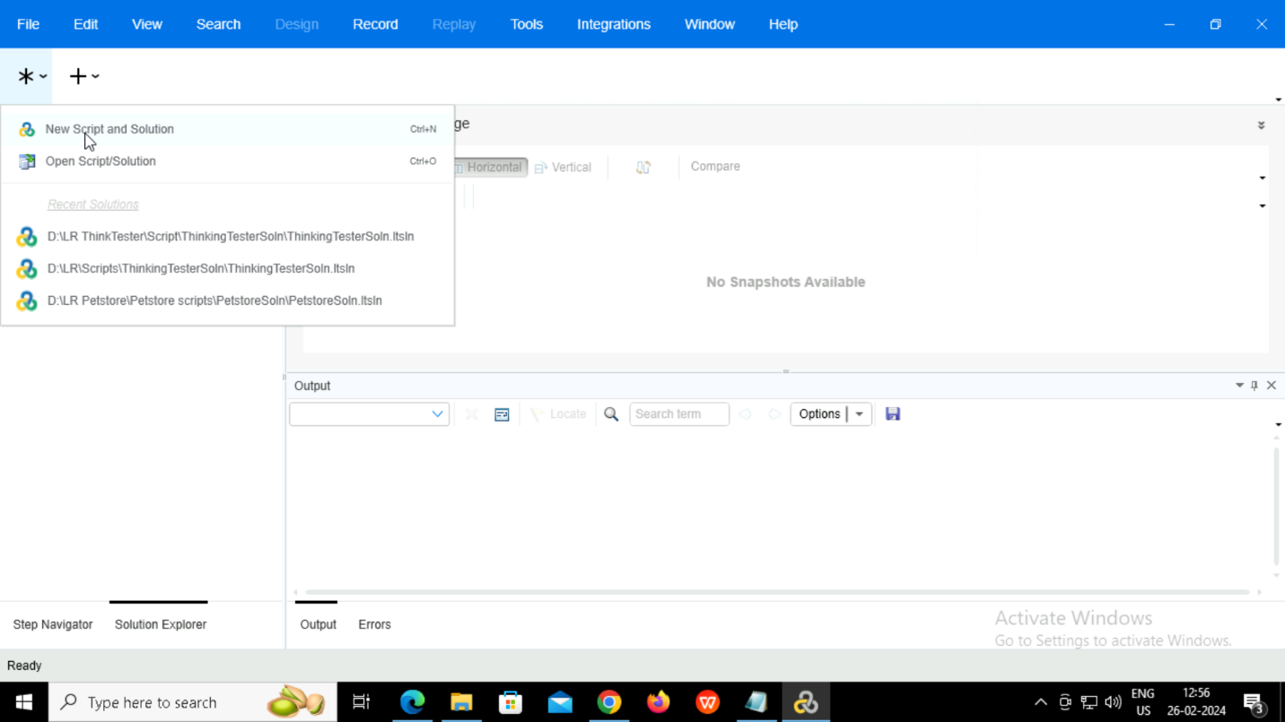

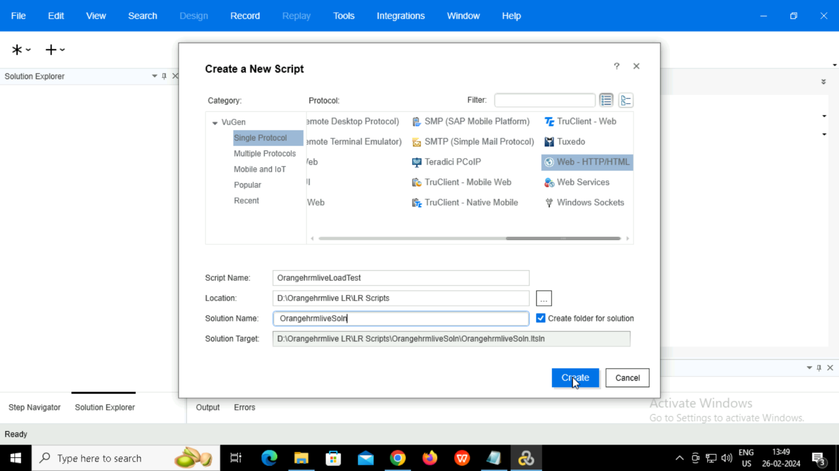

Tools 🡪 Options 🡪 Scripting 🡪Replay

Checking the ‘Show runtime viewer during replay’ to watch replay parallelly.

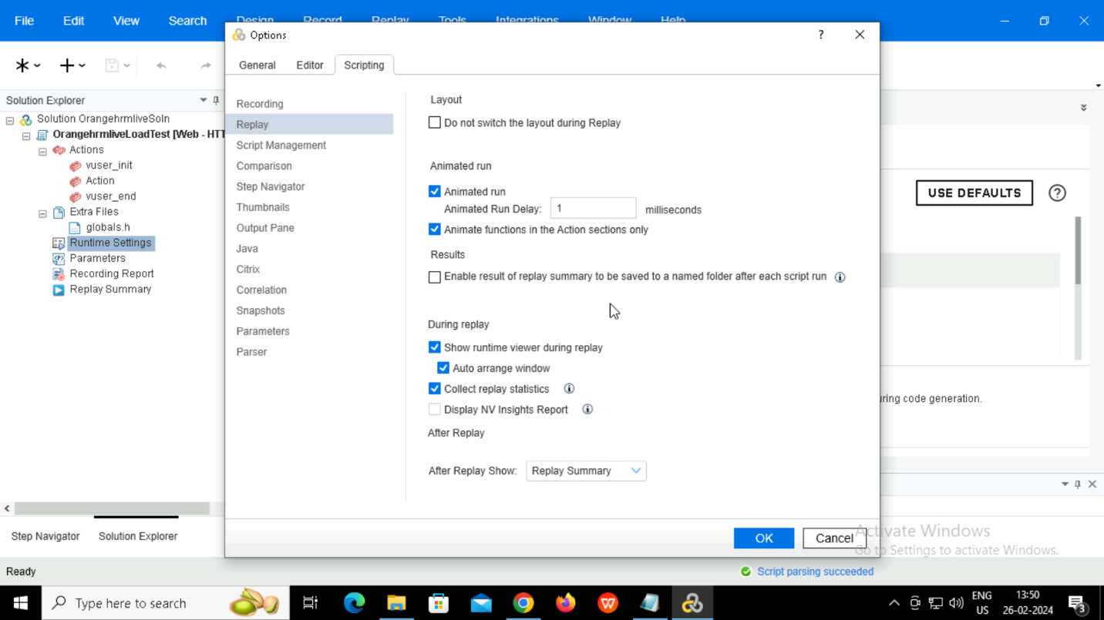

Tools 🡪 Options 🡪 Scripting 🡪Correlation

To enable correlation from replay snapshots.

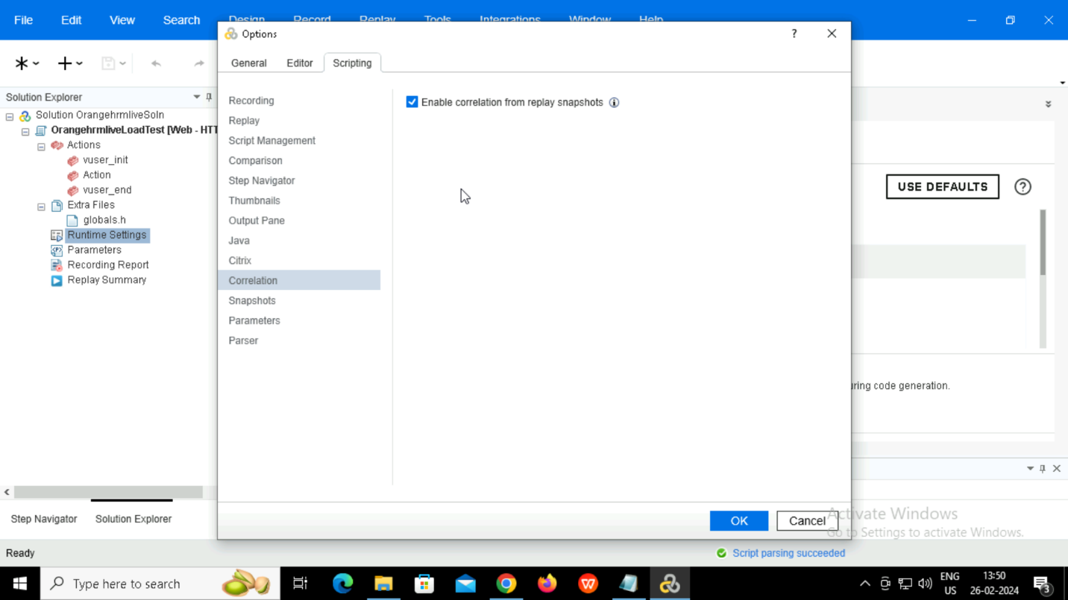

Runtime settings 🡪 Log 🡪 Extended Log 🡪 Parameter substitution.

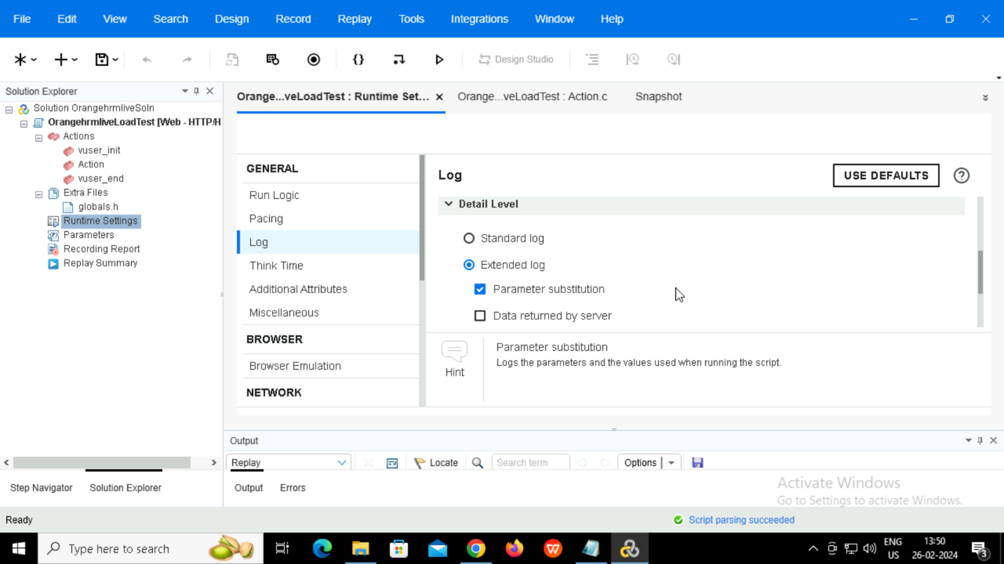

Runtime settings 🡪Preferences 🡪Check- ‘ Enable image and text checks’ to test the texts and images.

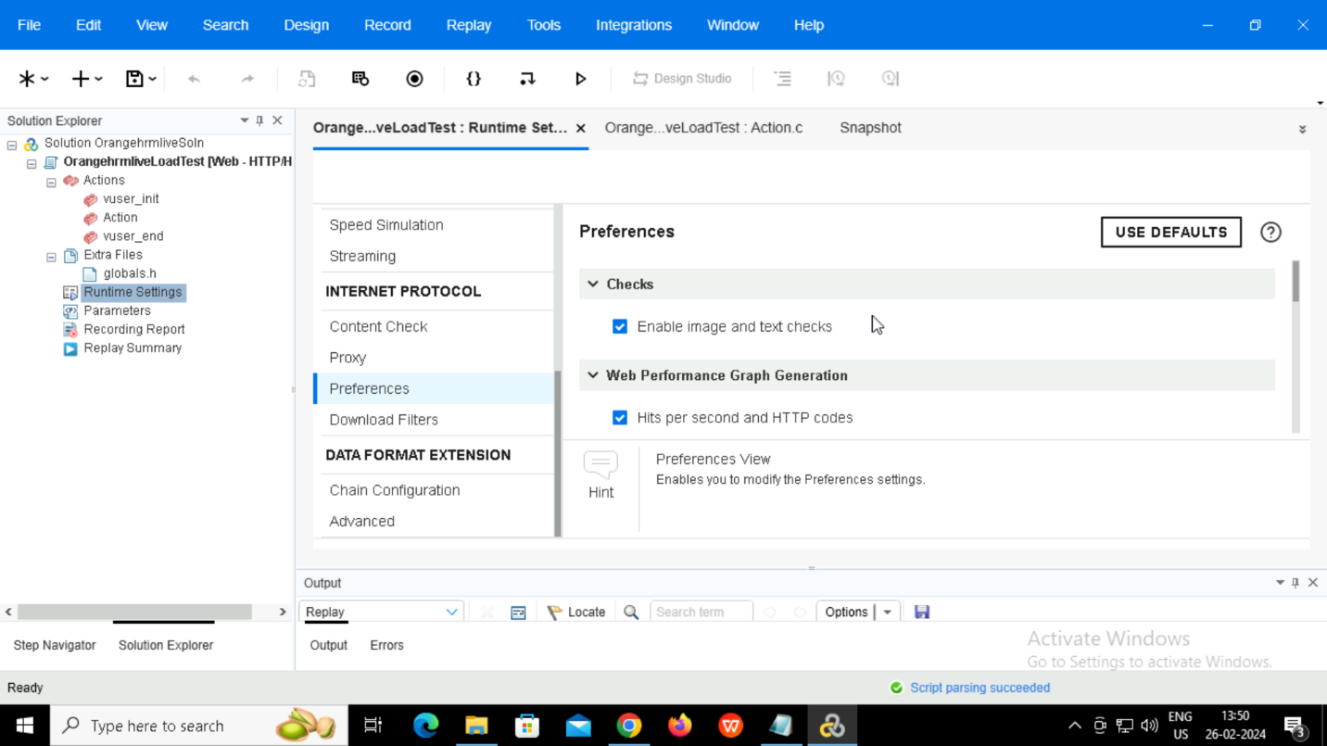

Setting number of iterations

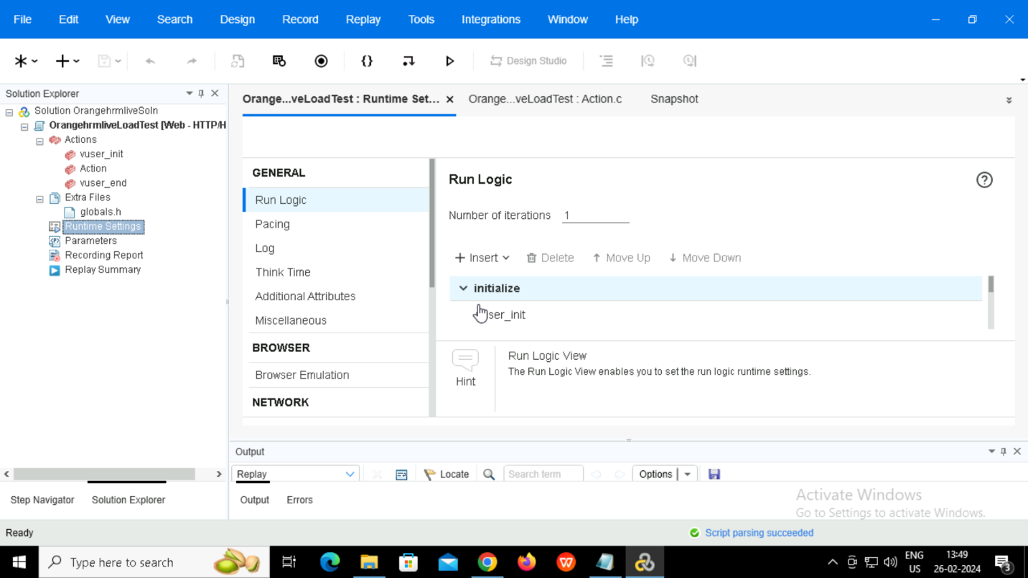

Clicking on record icon.

Selecting the browser.

Providing the link of the site.

Selecting the folder to which the recording should be saved.

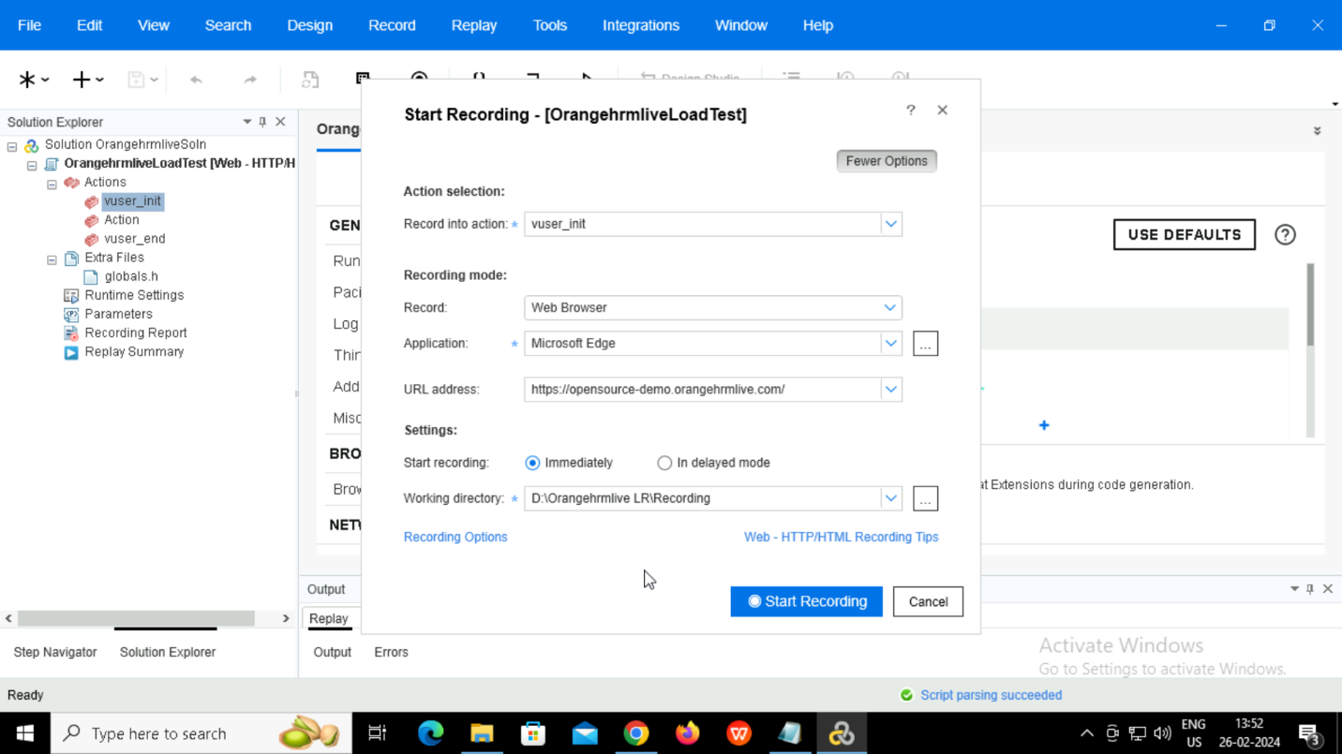

Recording options 🡪Configuration

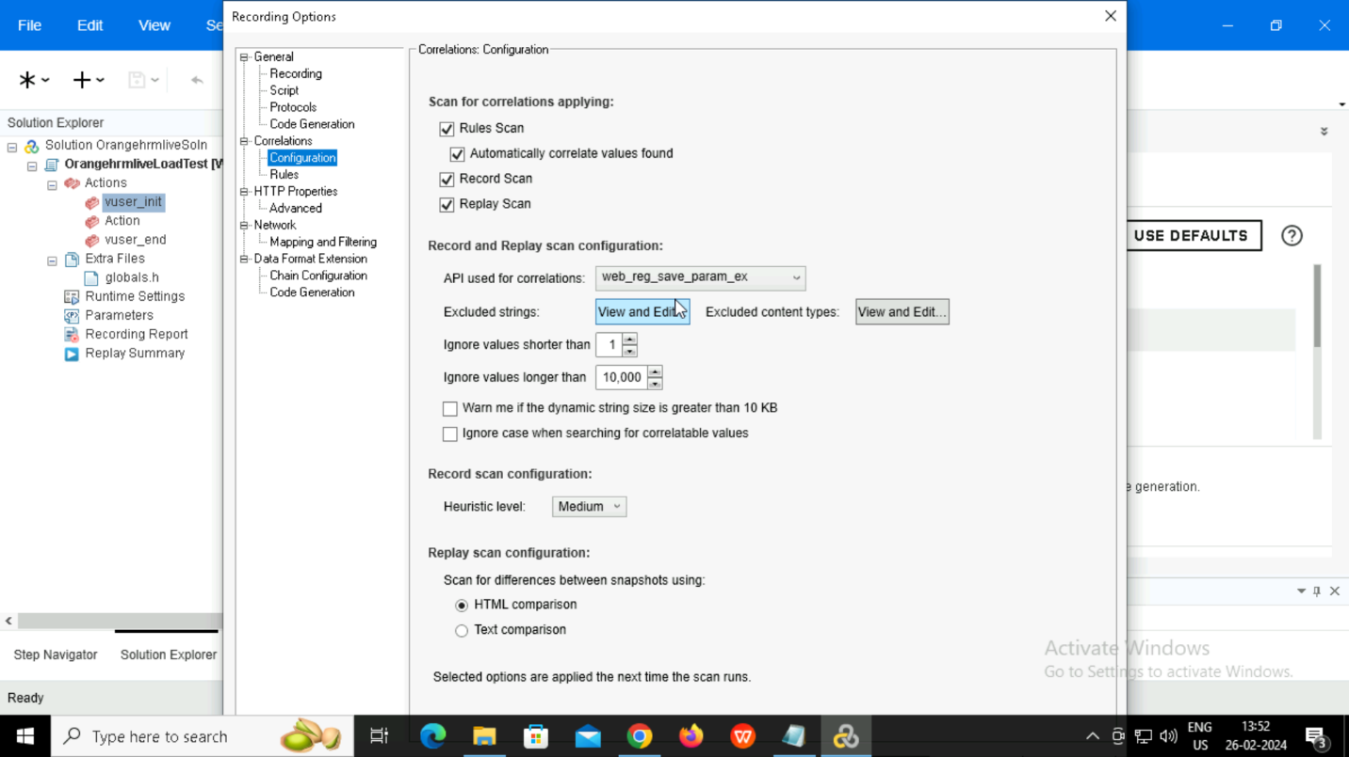

Recording options 🡪Recording

Selecting HTML based script

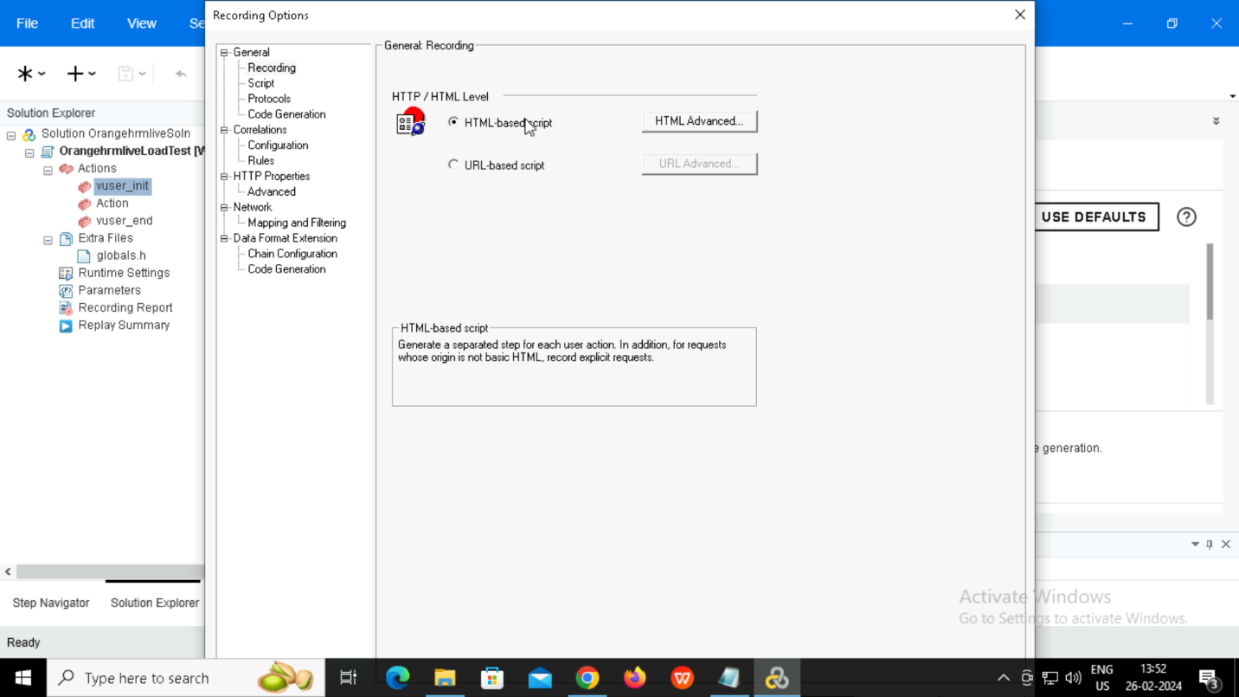

Selecting HTML advanced.

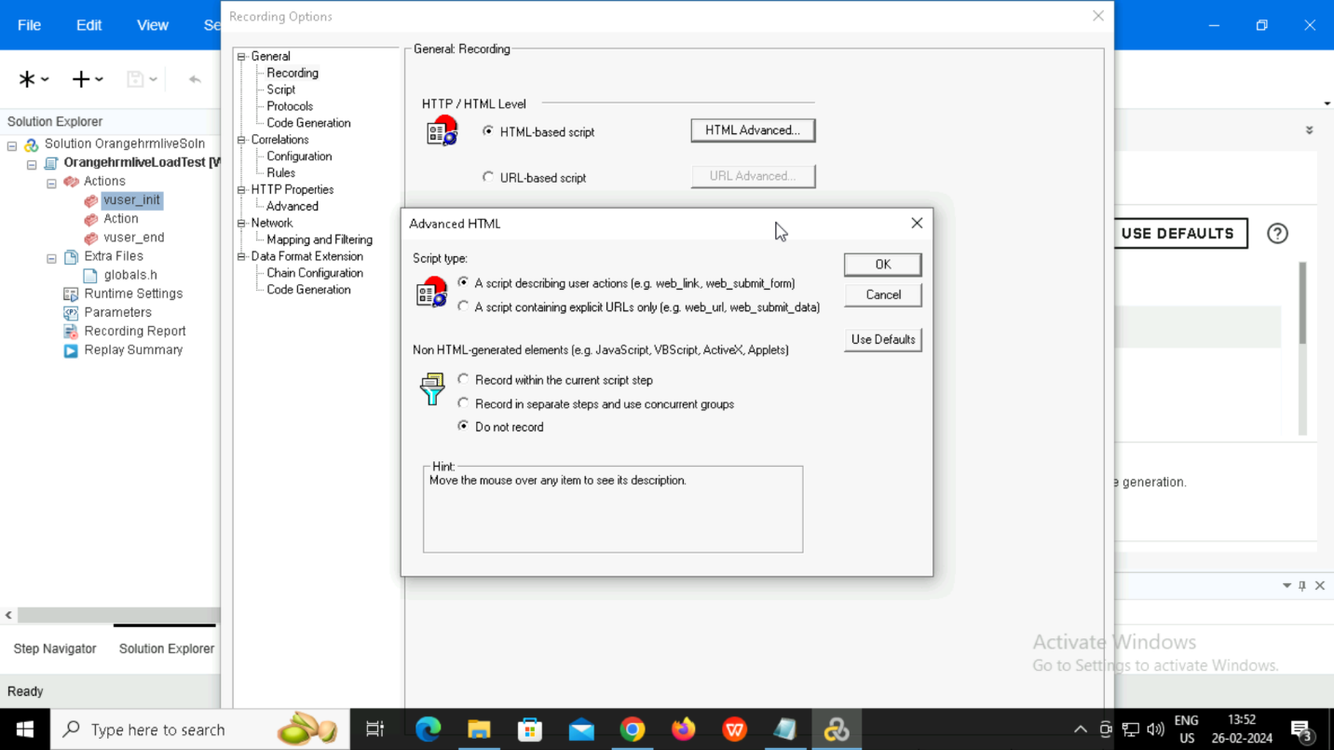

Recording options 🡪Mapping and filtering.

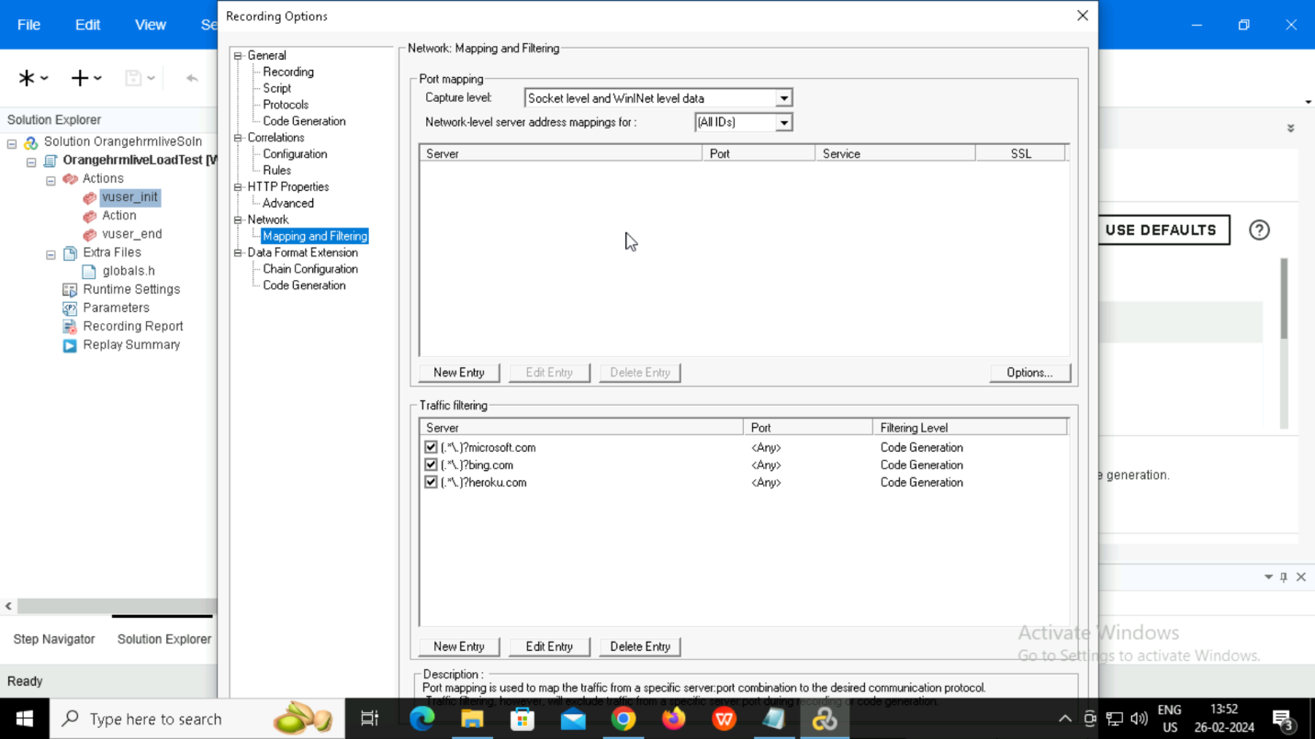

Start to record

Adding comments for each page.

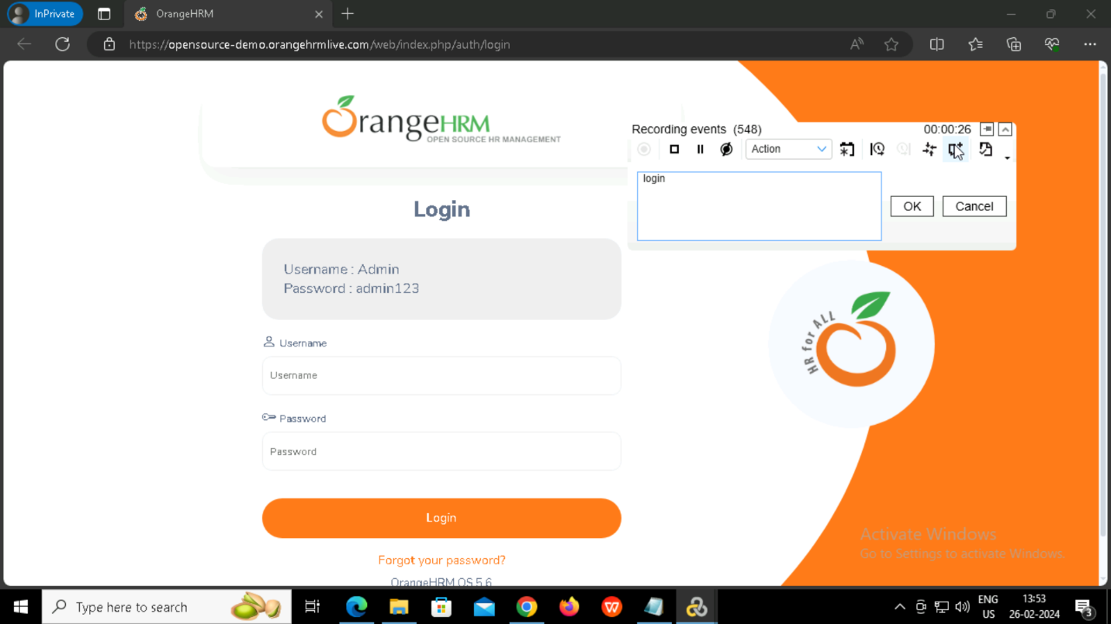

Claim page

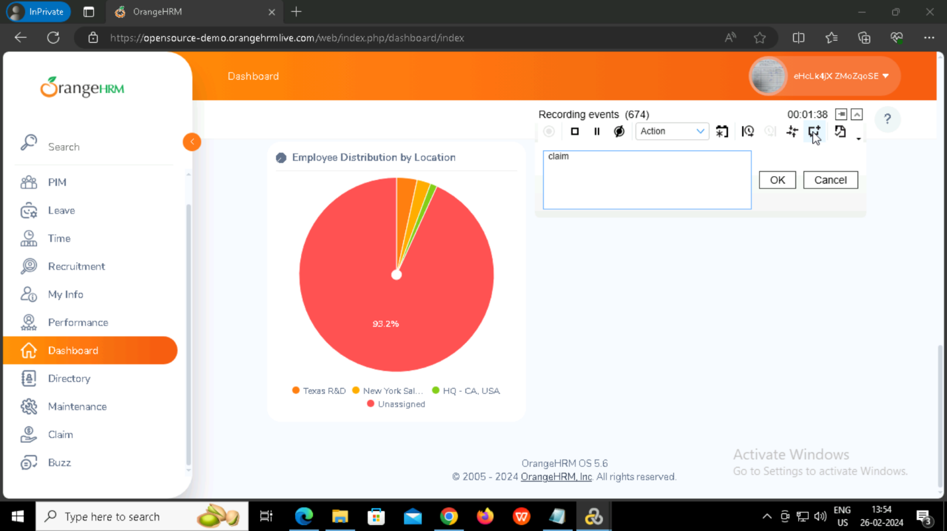

Searching claim

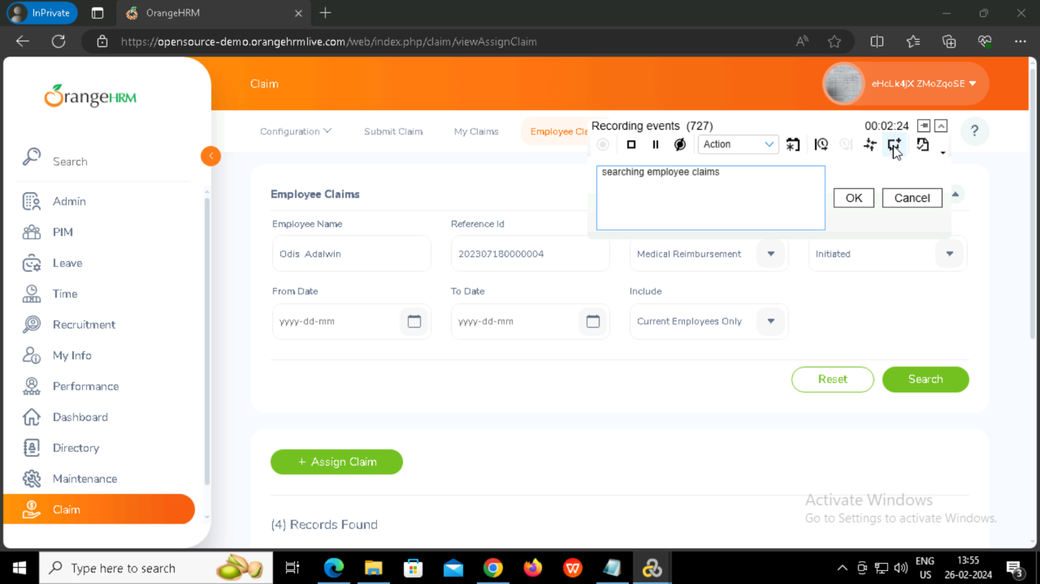

View details page

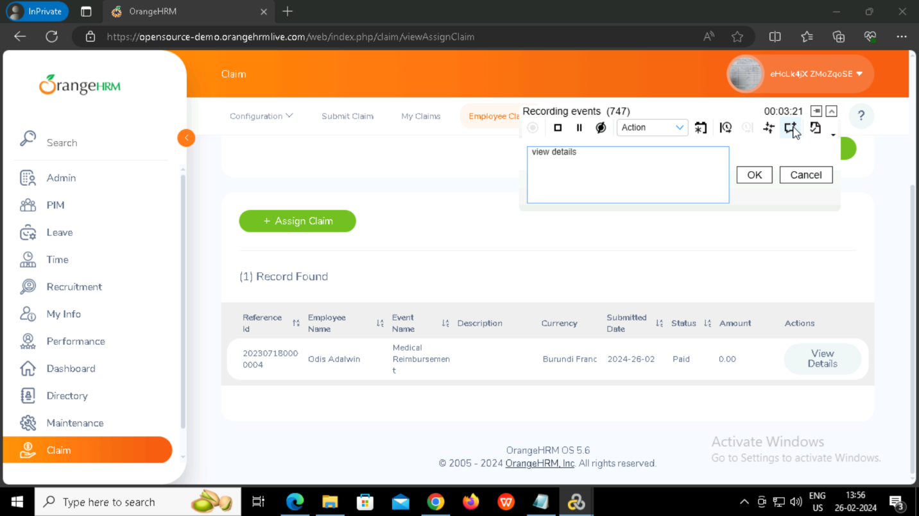

Back

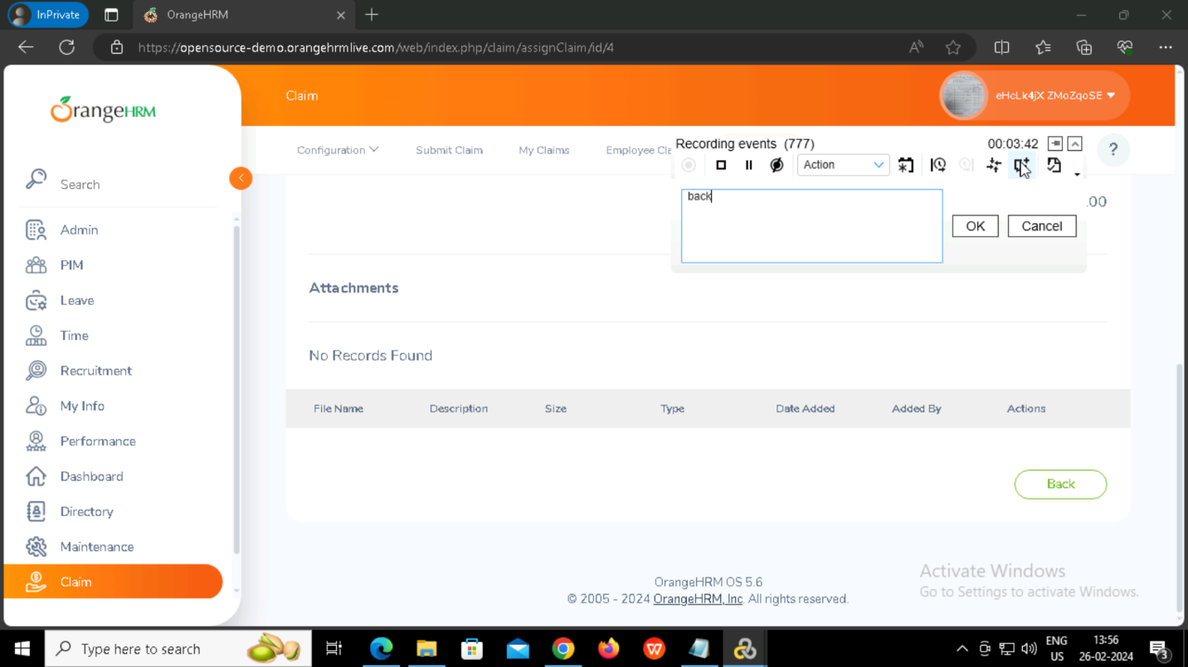

User logout

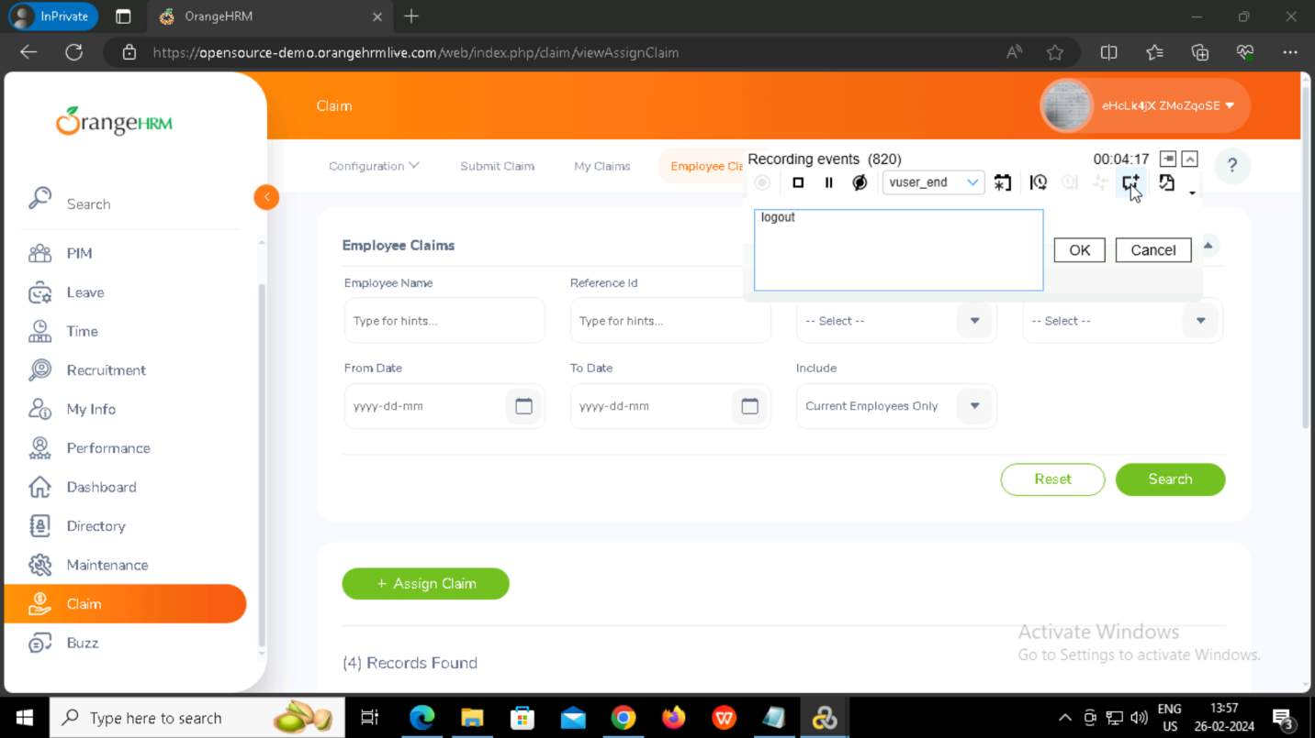

Stopped the recording and the code will be generated.

Vuser_init

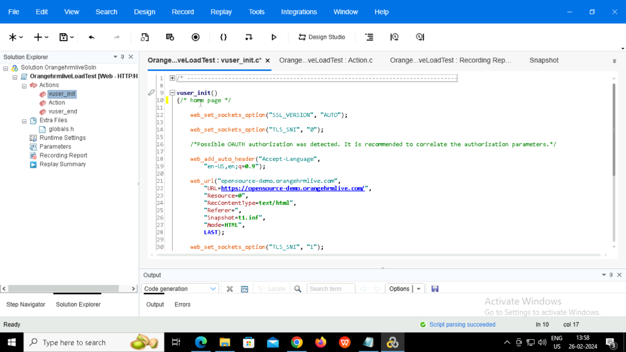

Action

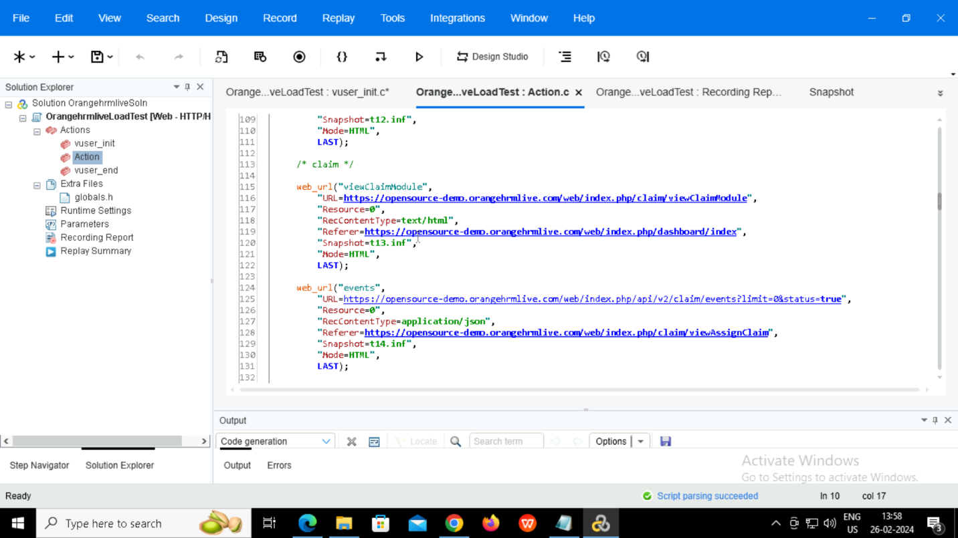

Vuser_end

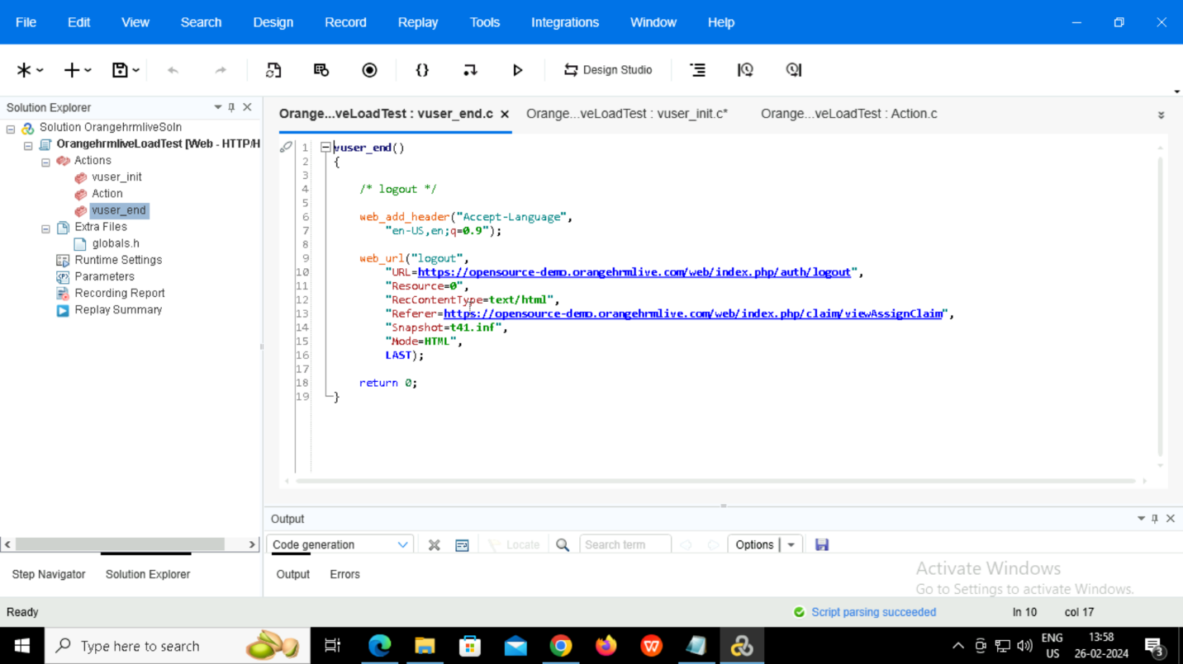

Replay the scrip

Here there are 2 errors

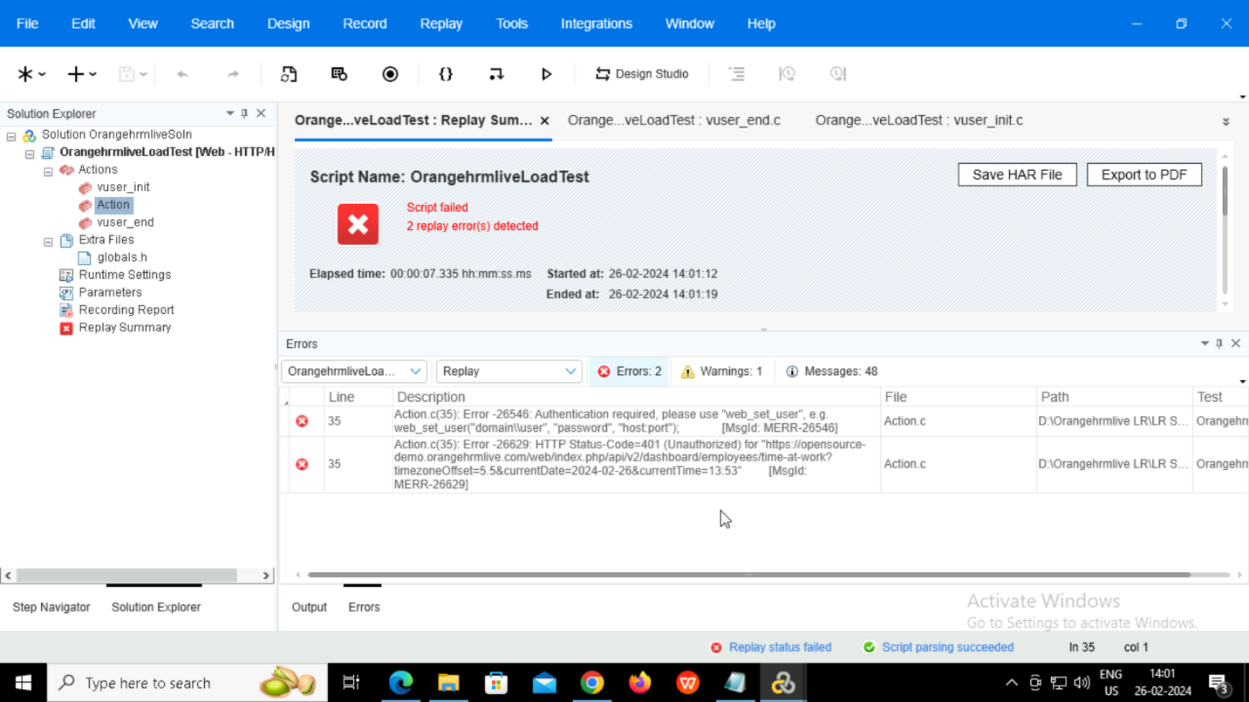

Opened the errors and the errors are in dashboard .

So, opened the snapshot and checked the issue.

View 🡪Snapshot

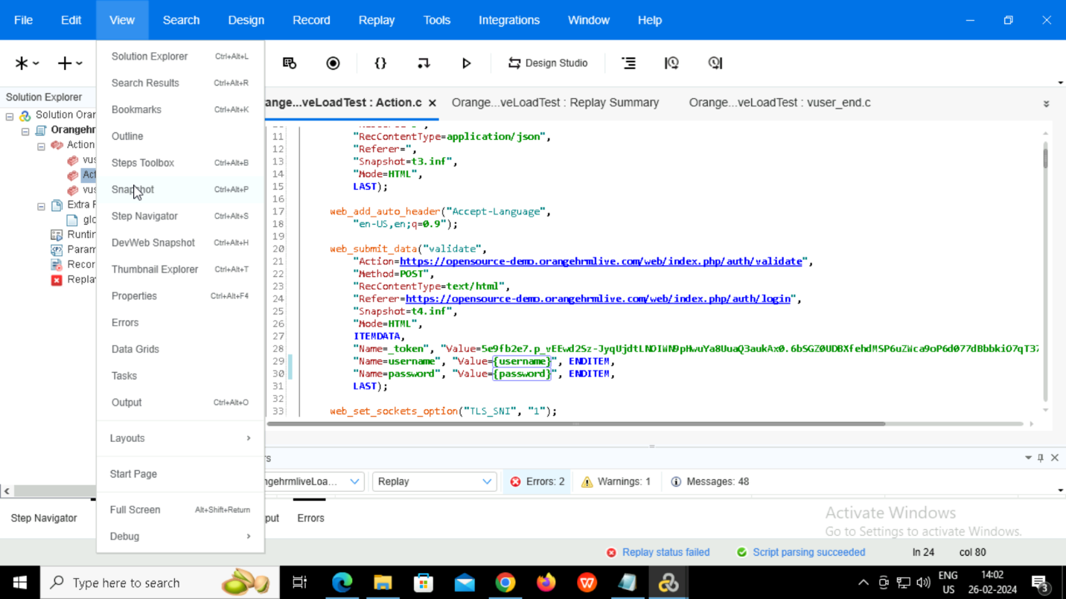

Splitting

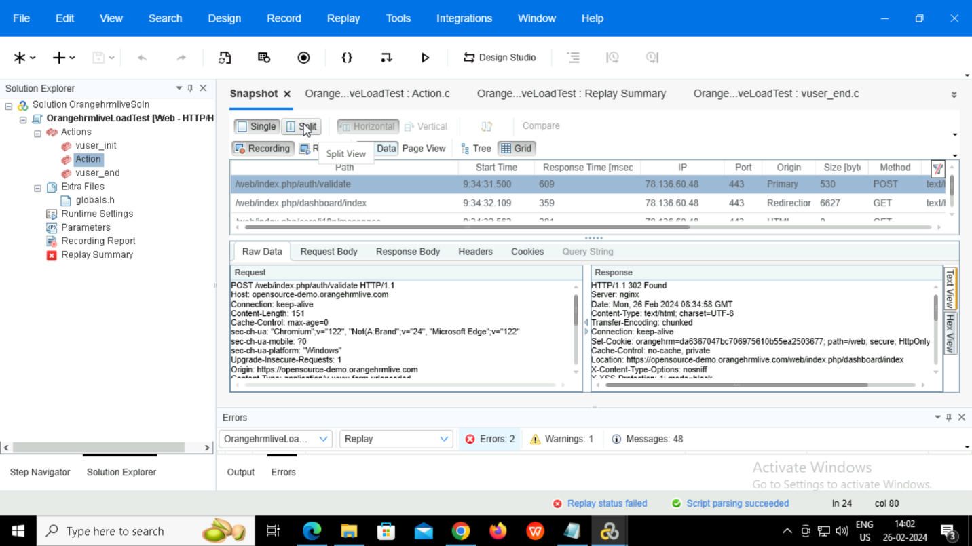

Checked the issue.Here authorization is required.The token is not being passed.So, correlation is required.

Correlation

Here auto-correlation is done.

Recording report 🡪Open design studio

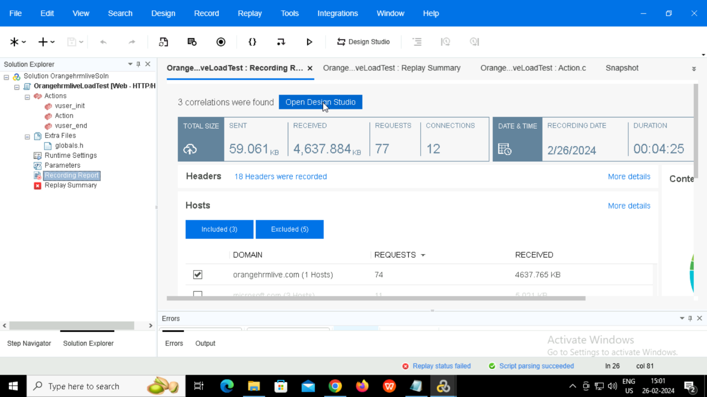

Choose the items 🡪 Correlate

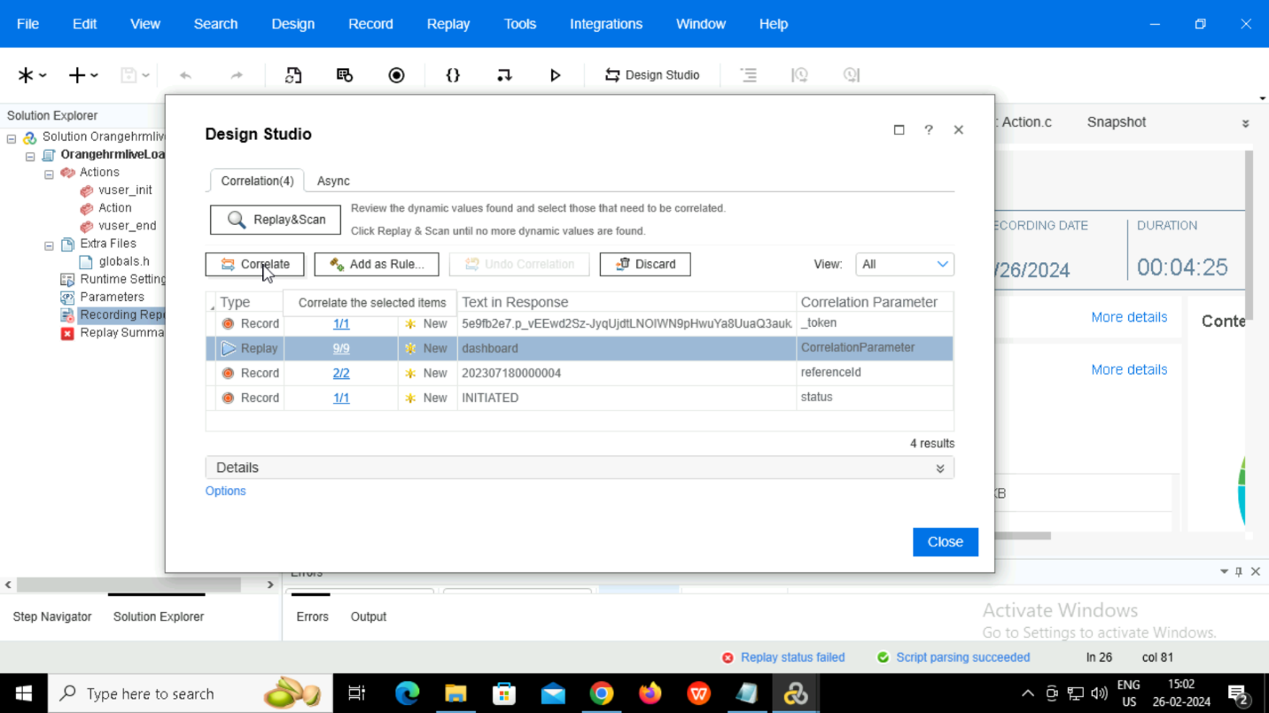

Then replay

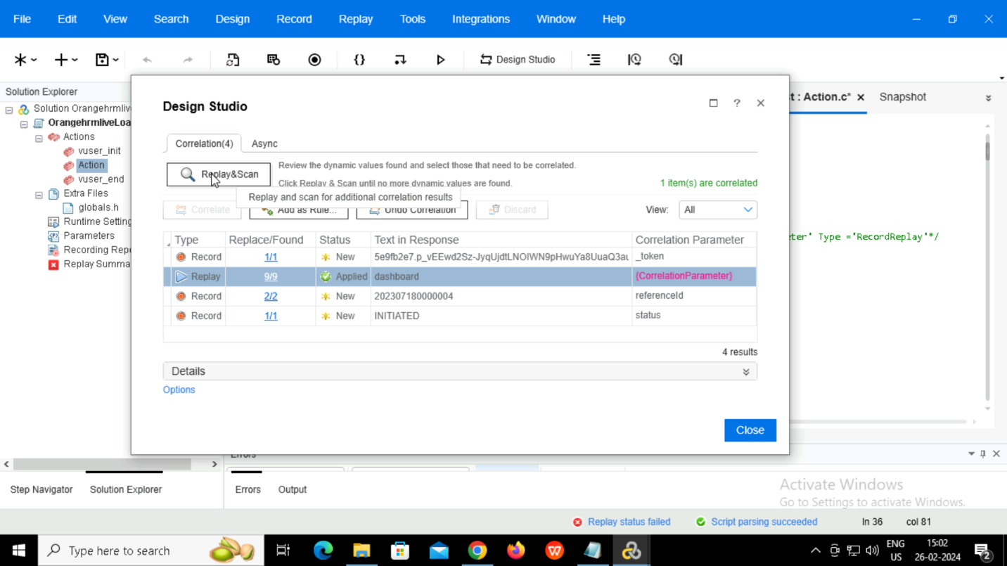

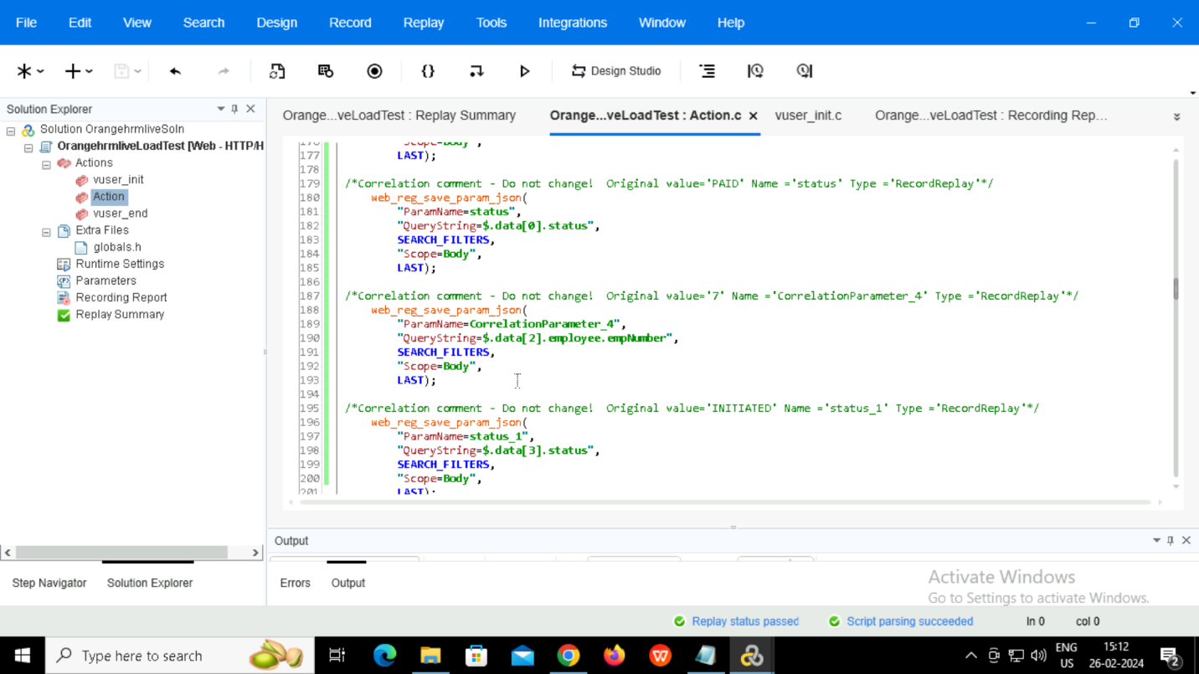

Now that the correlation is done, and the replay script is passed.

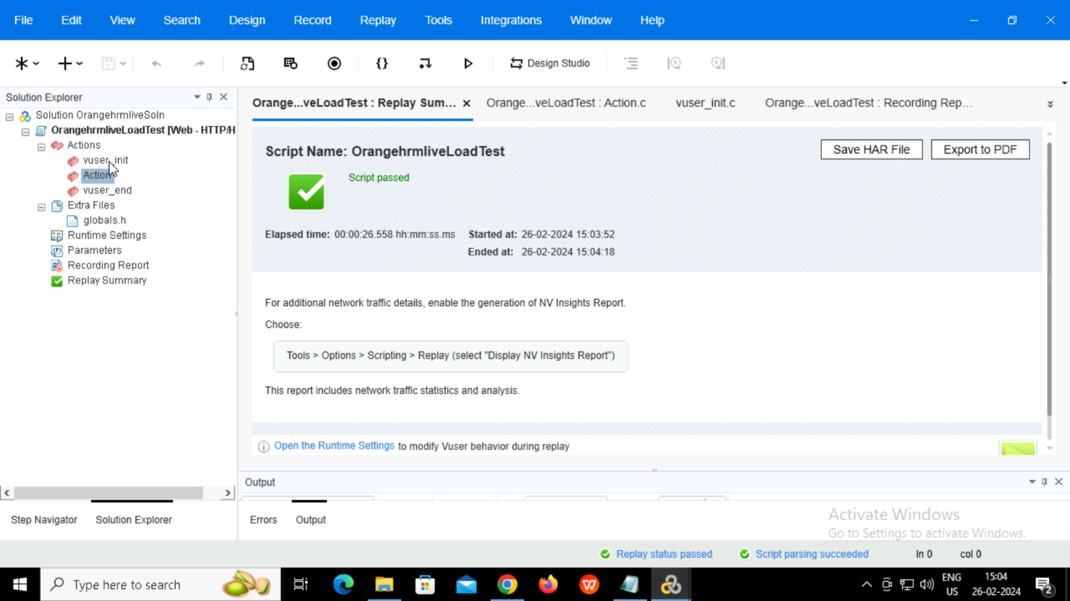

Parameterization

Select the value to add parameter and right click.

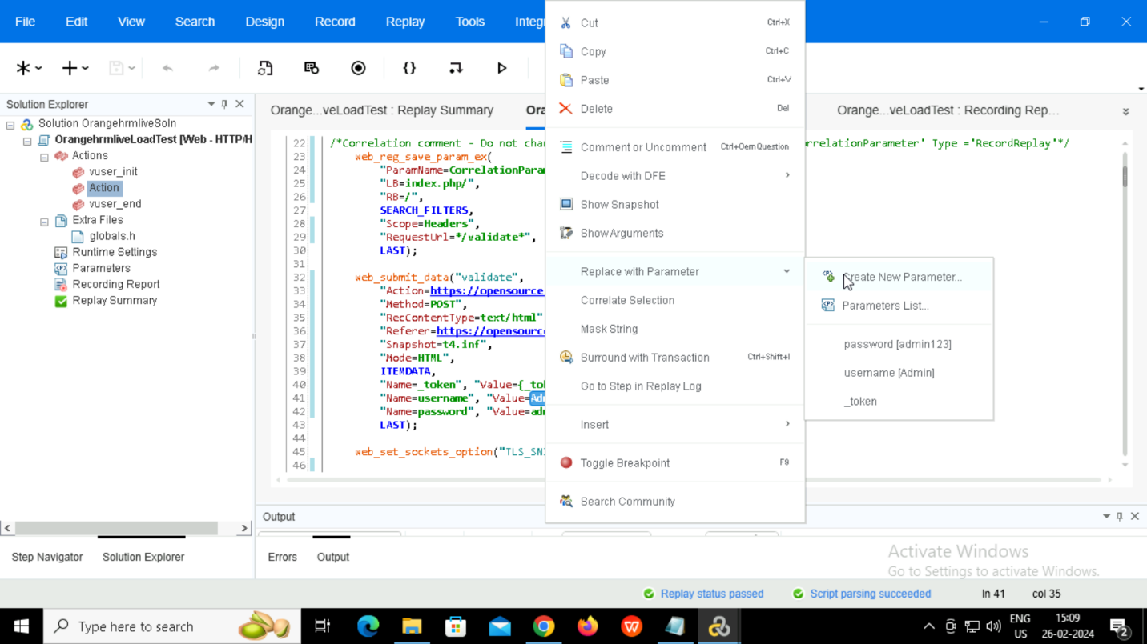

For login credentials we have created a table named ‘loginDetails’ and added two parameters for email and password.

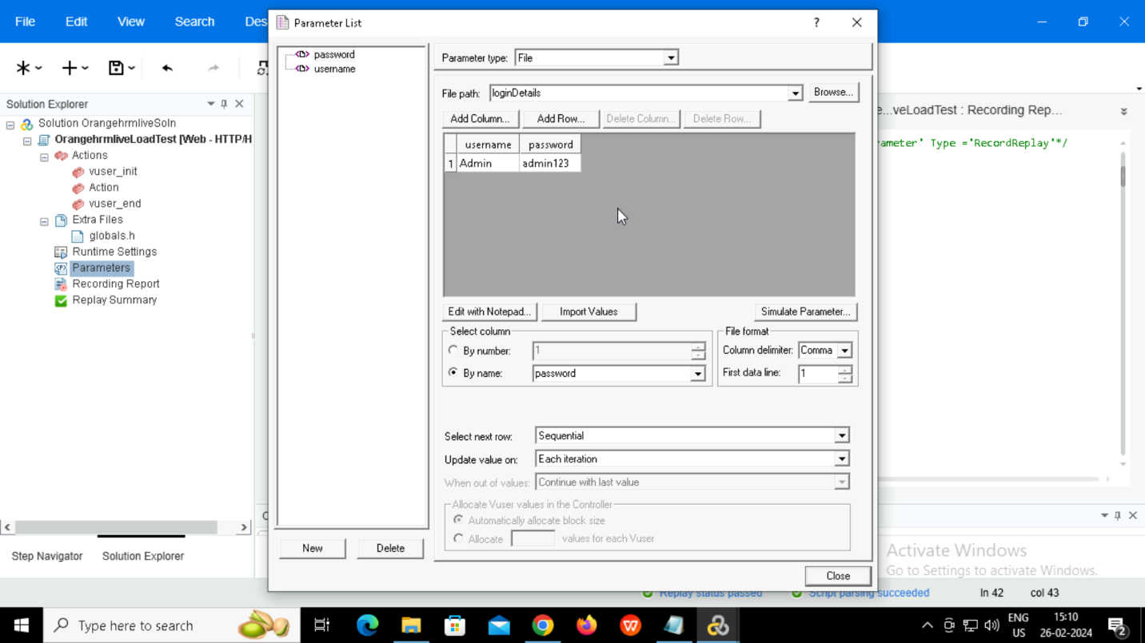

Text check

Include this line of code for text check.

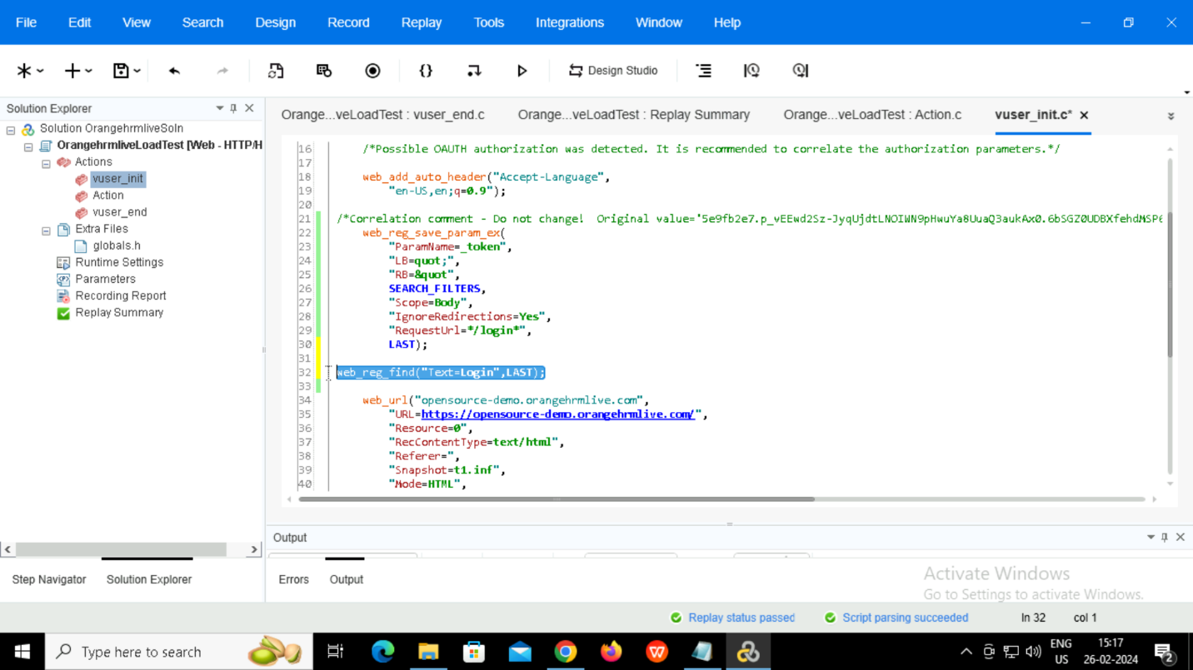

Text test passed.

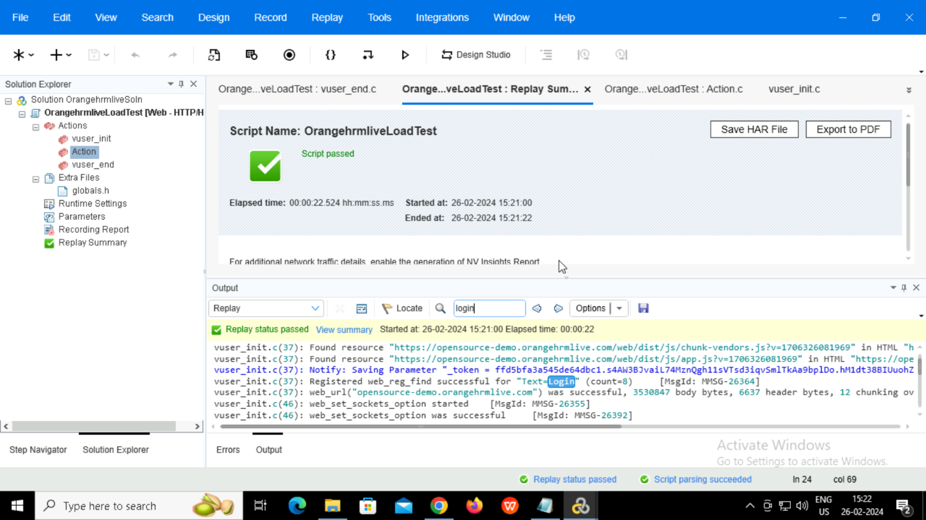

Image check

For image check adding this line to the code.

**2.Controller**

Going to controller and adding script.

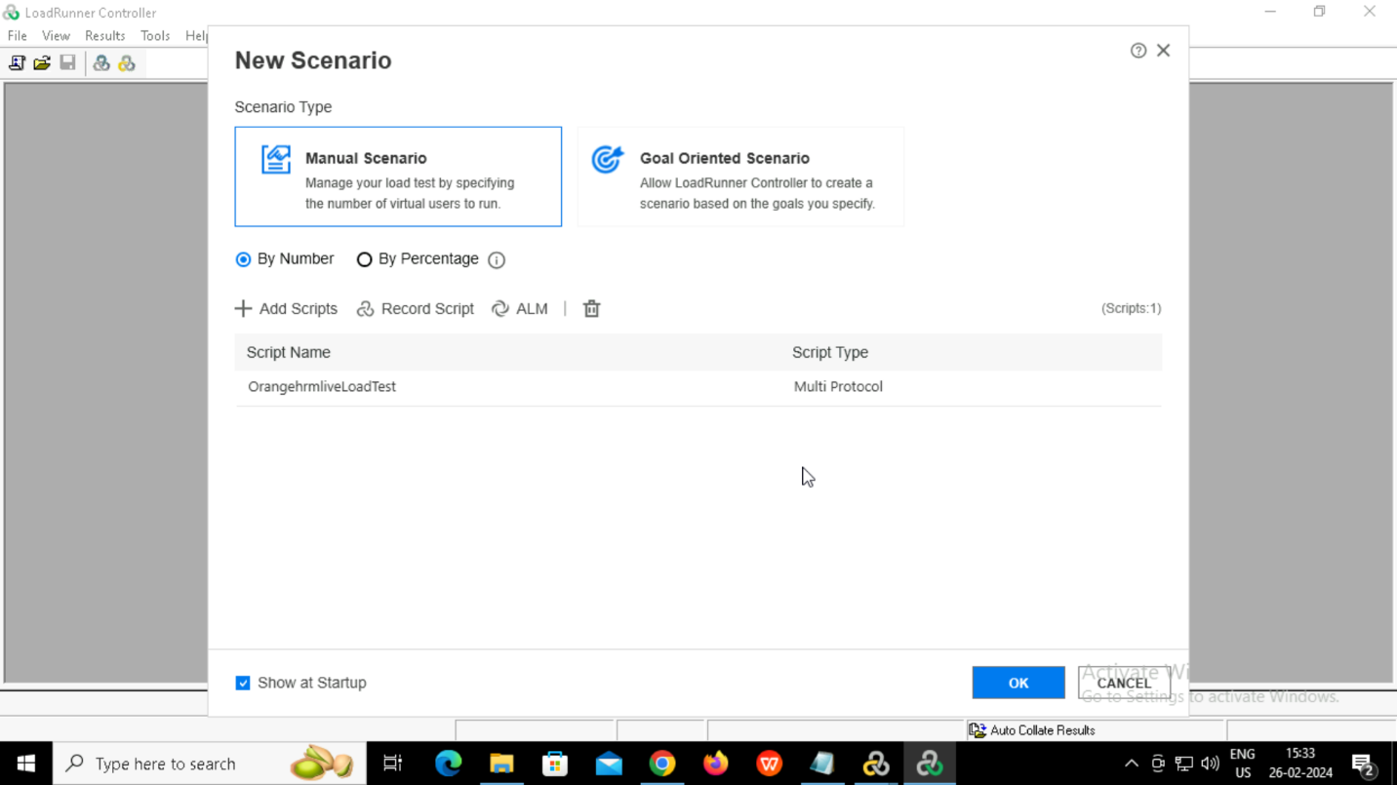

Adding Vusers

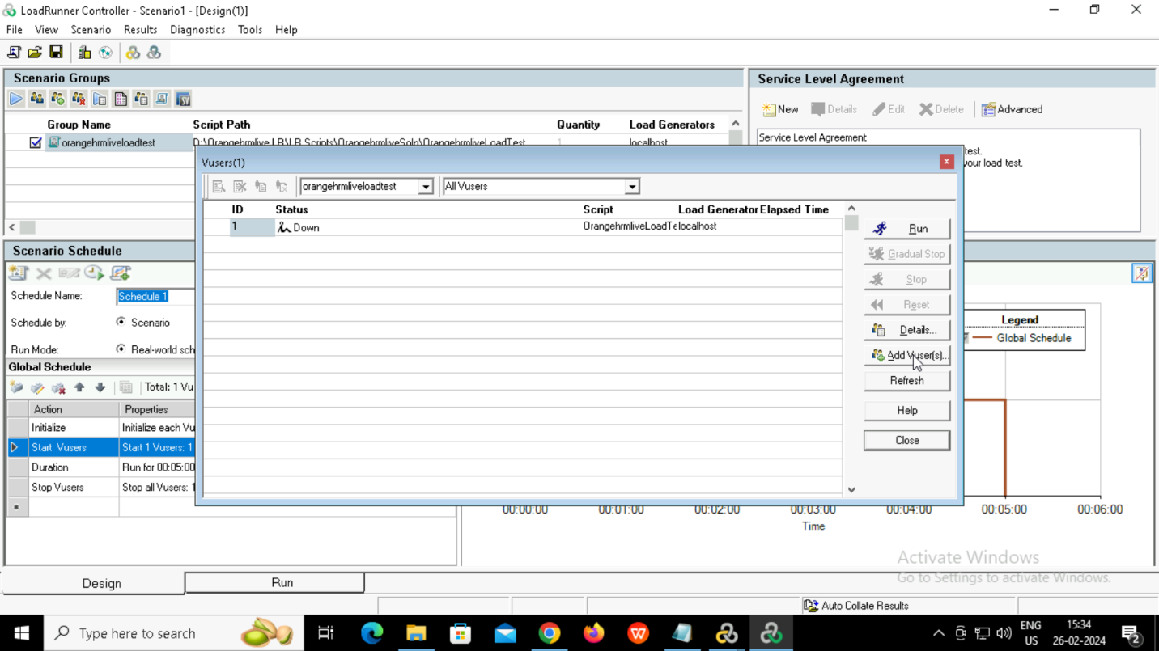

Added 3 vusers

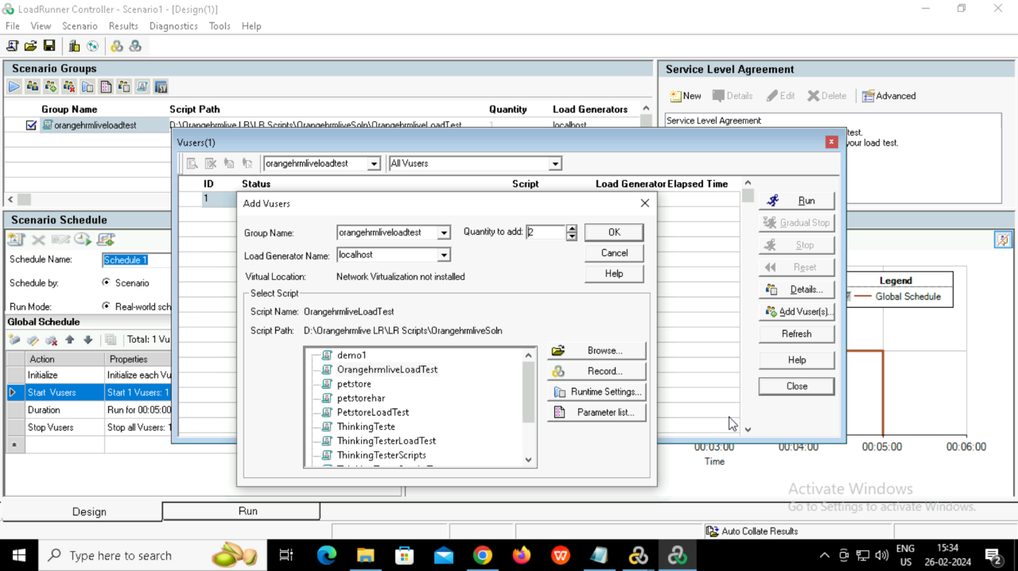

Set duration as 2 minutes.

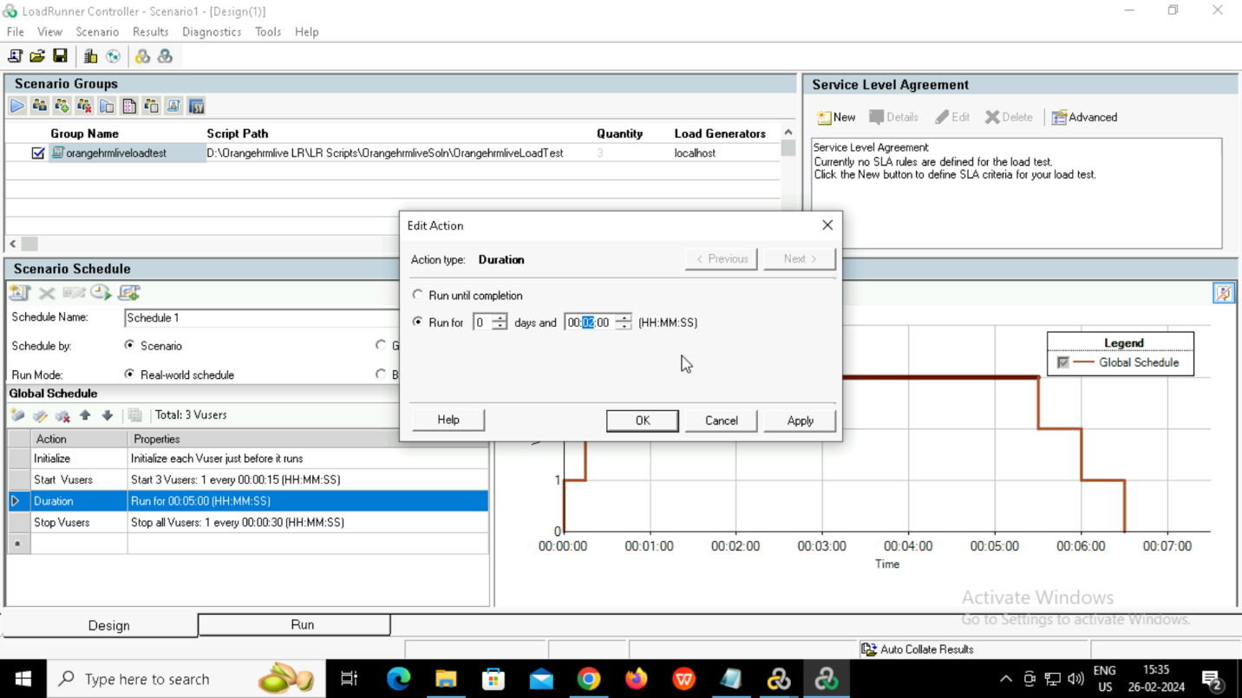

Stop Vusers as 15 seconds.

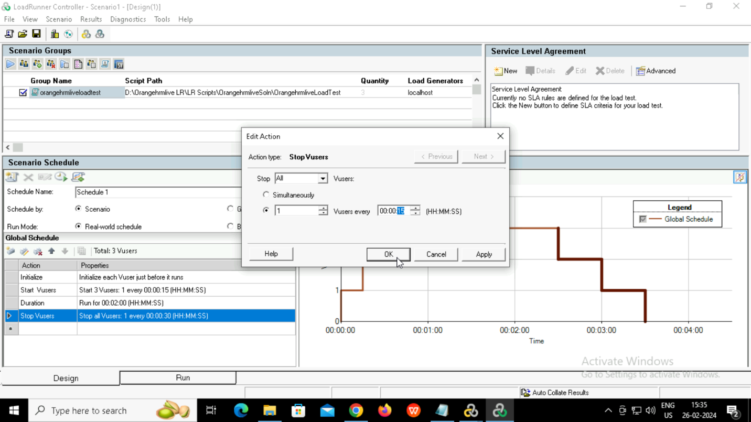

Started the scenario.

Selected the required graphs.

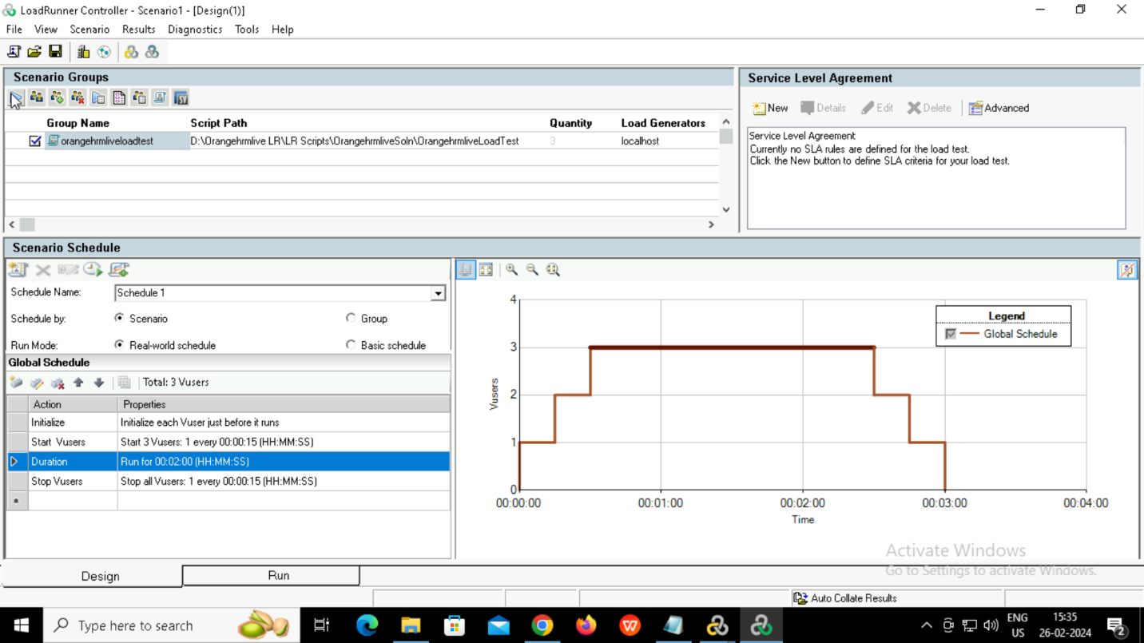

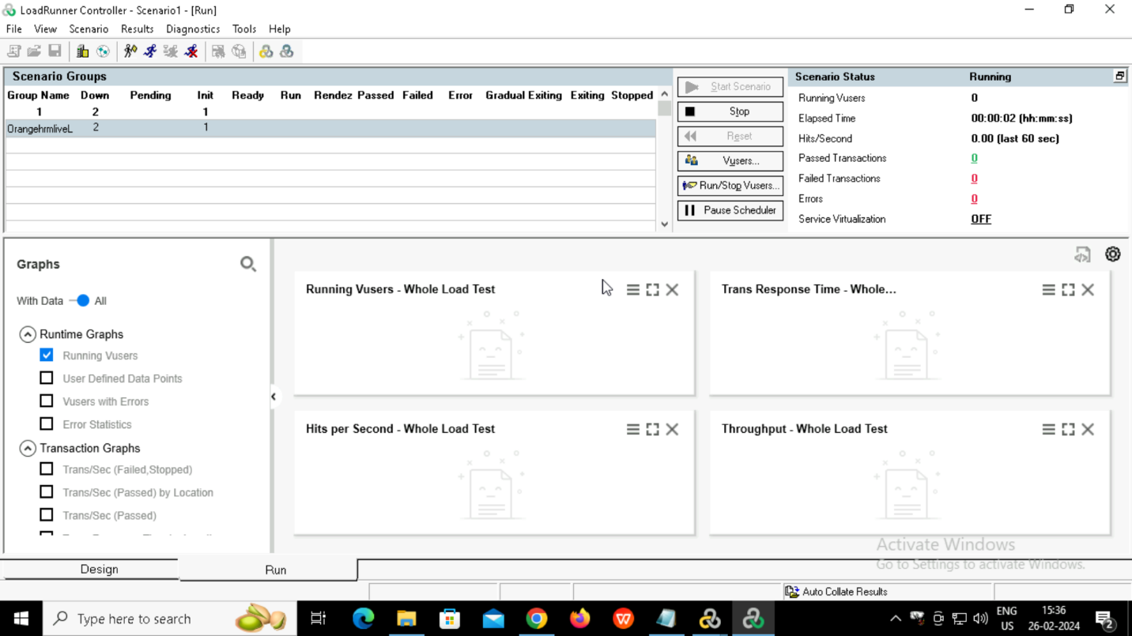

Got all the selected graphs

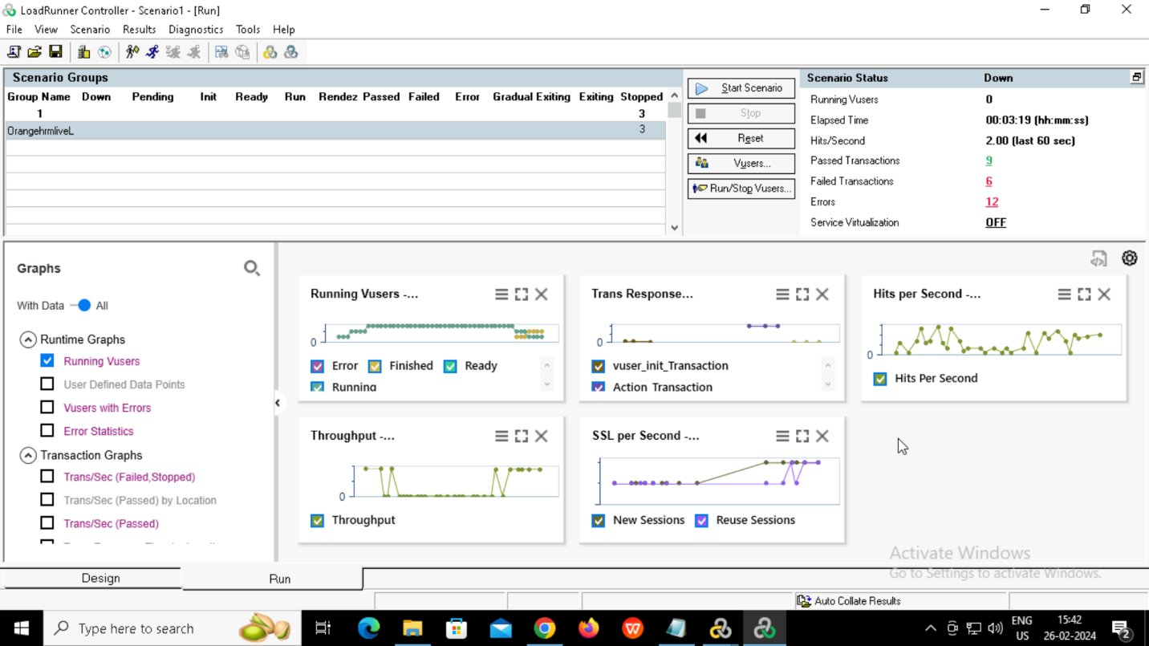

Moving to analyzer.

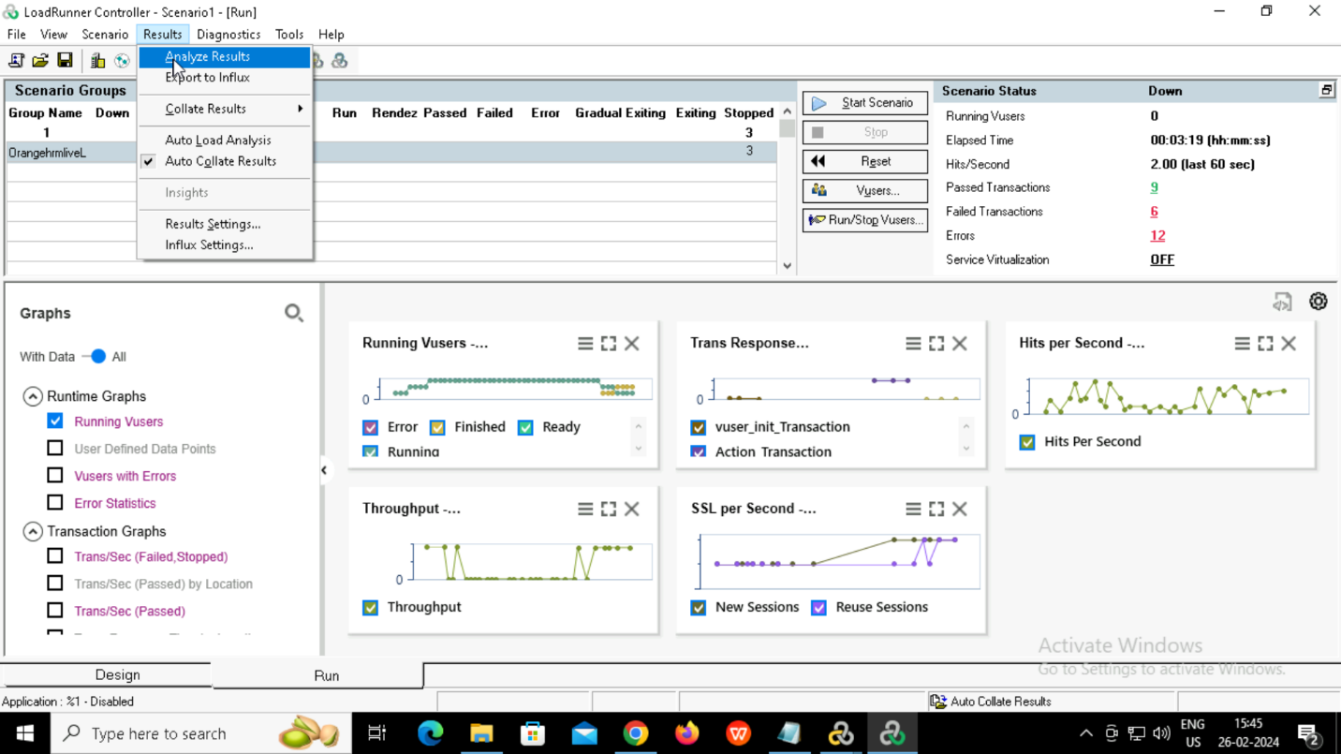

**3.Analyzer**

Summary report.

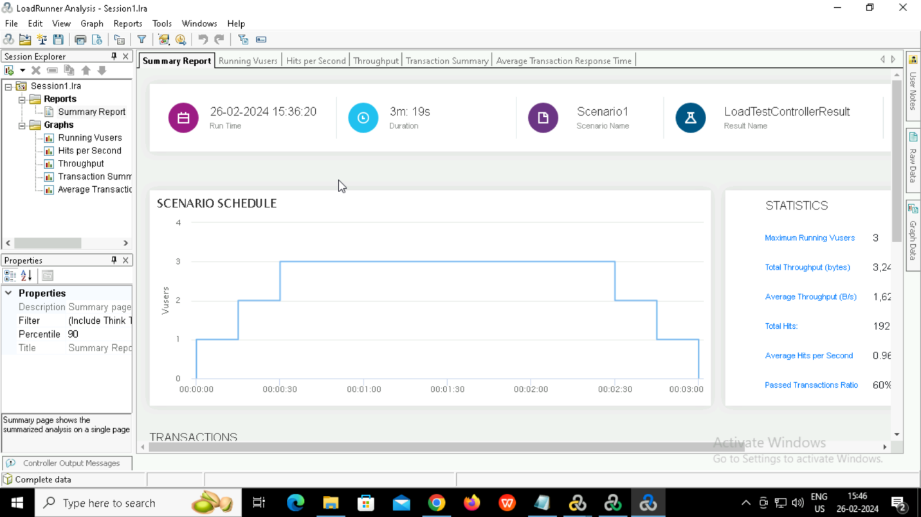

Running vusers

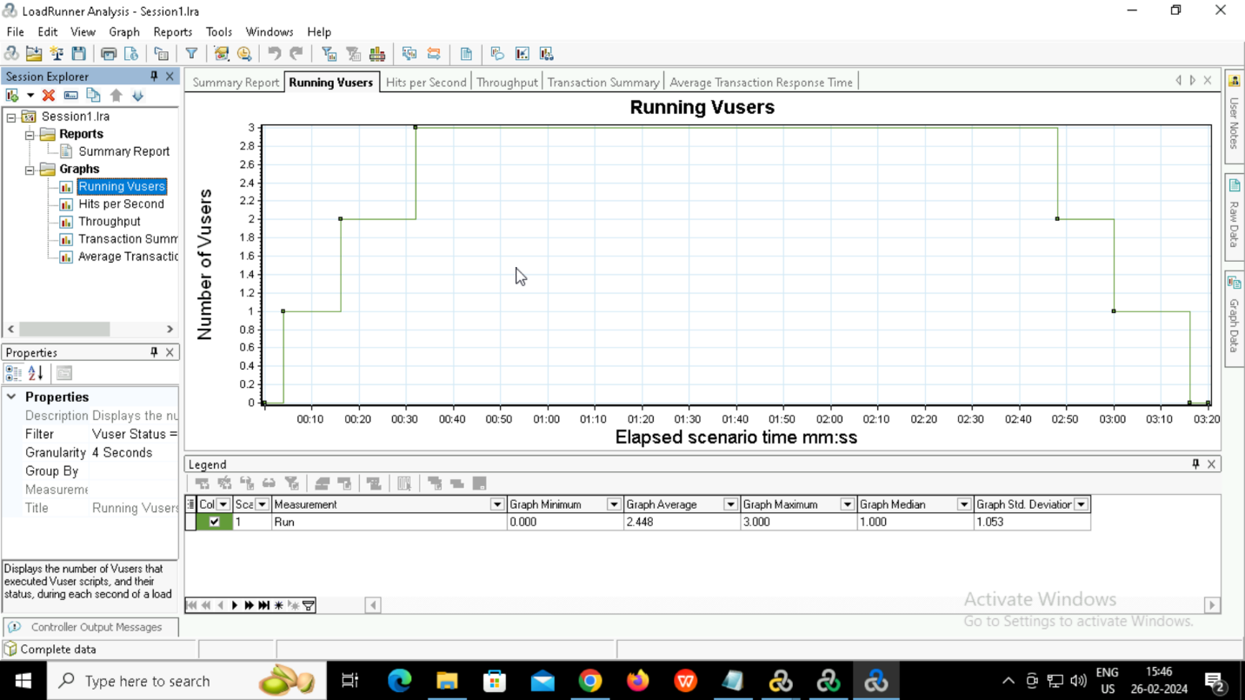

Hit per second.

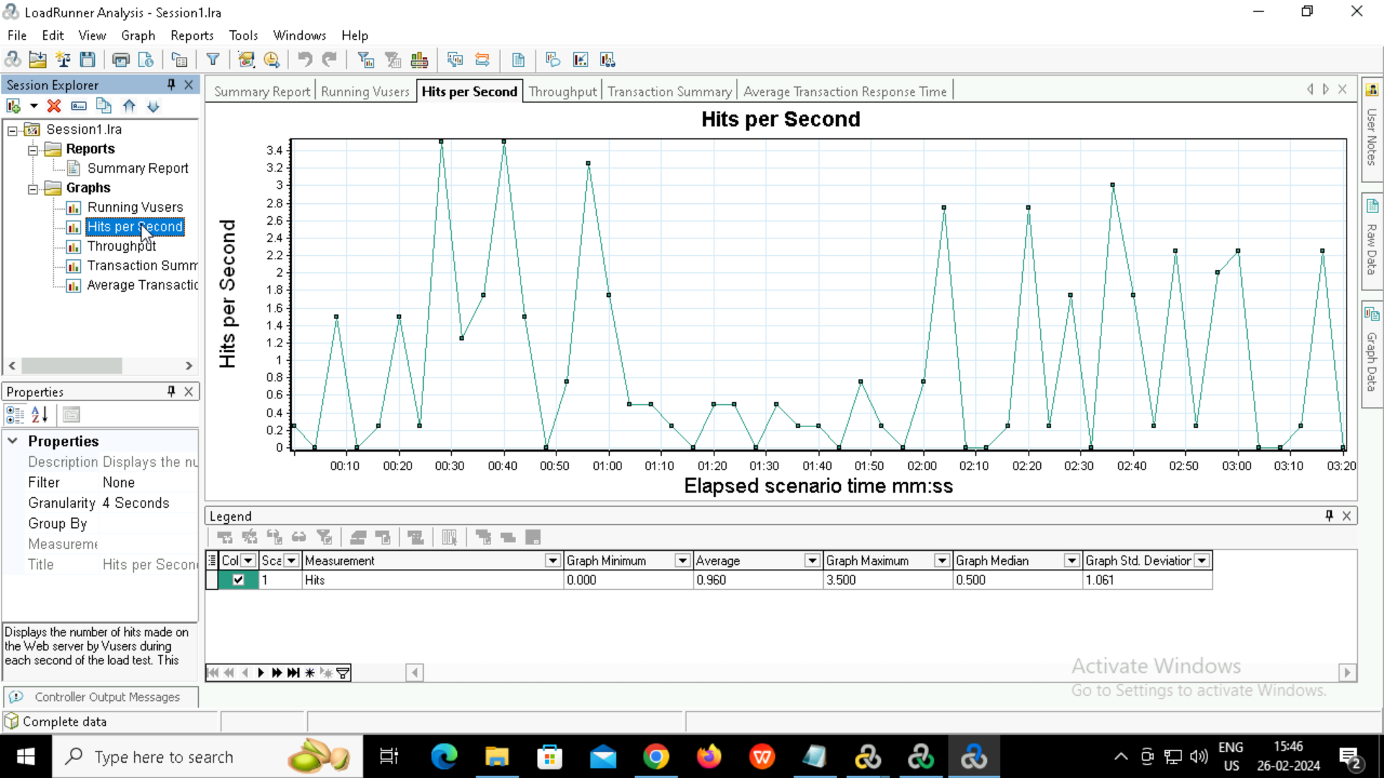

Throughput

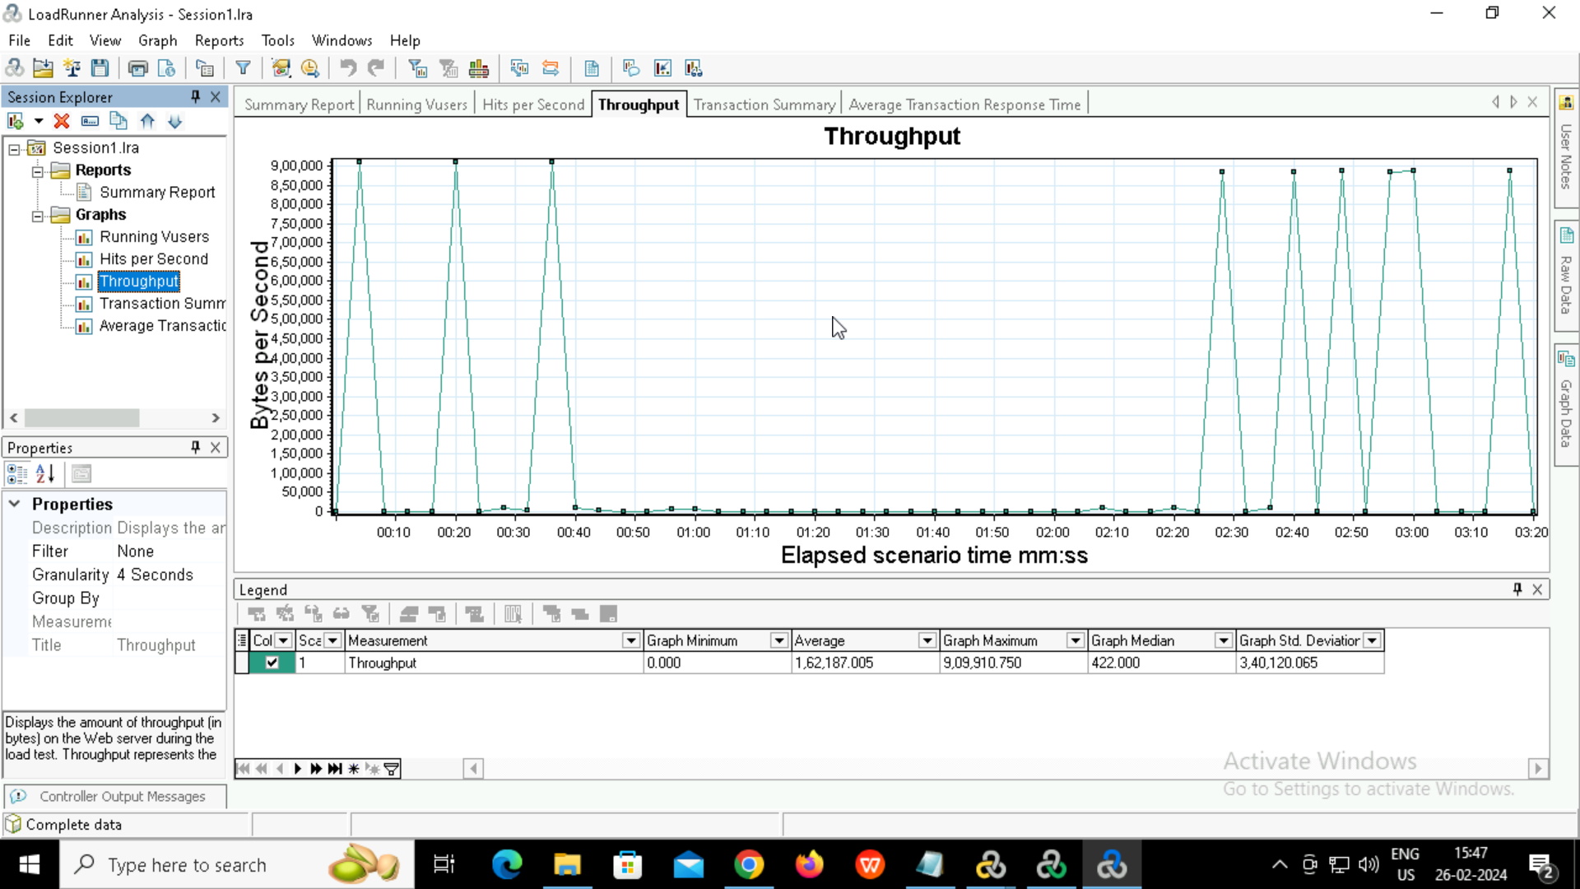

Adding comments.

Right click on the point 🡪Comments 🡪Add

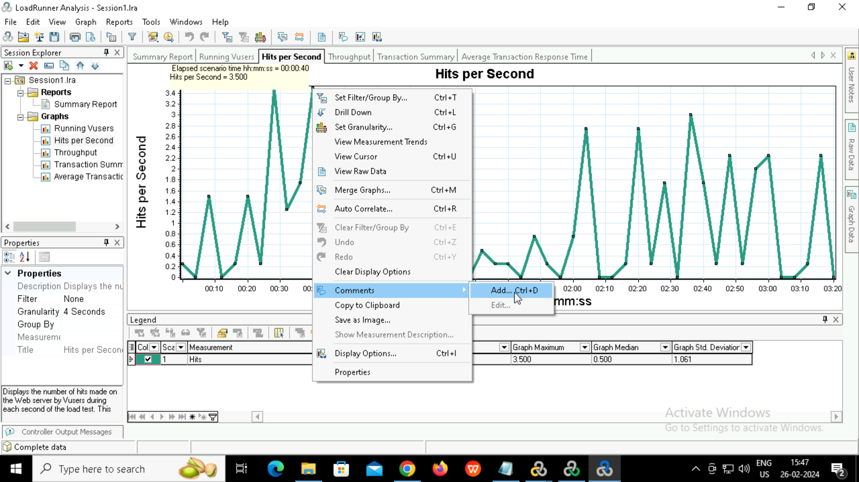

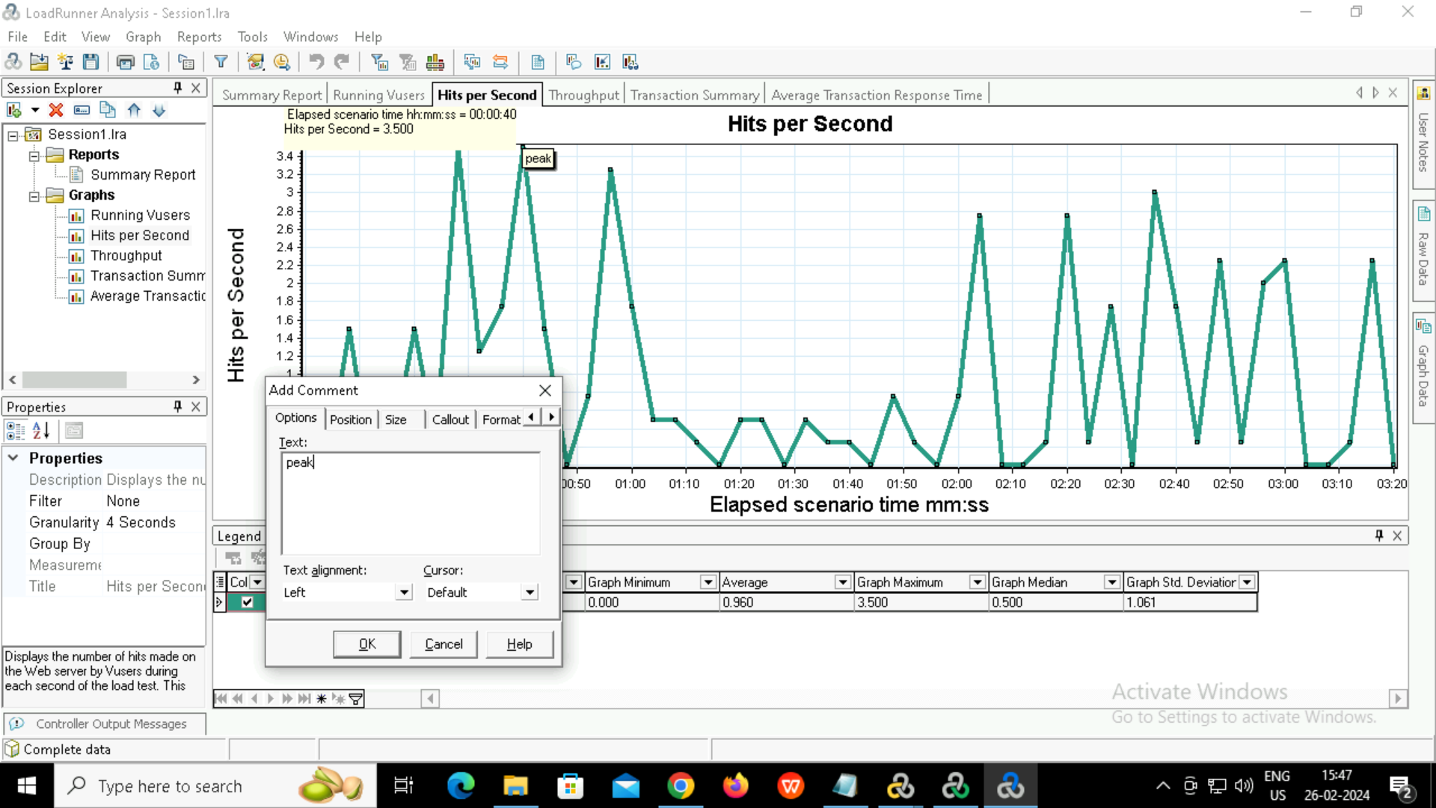

Transaction summary

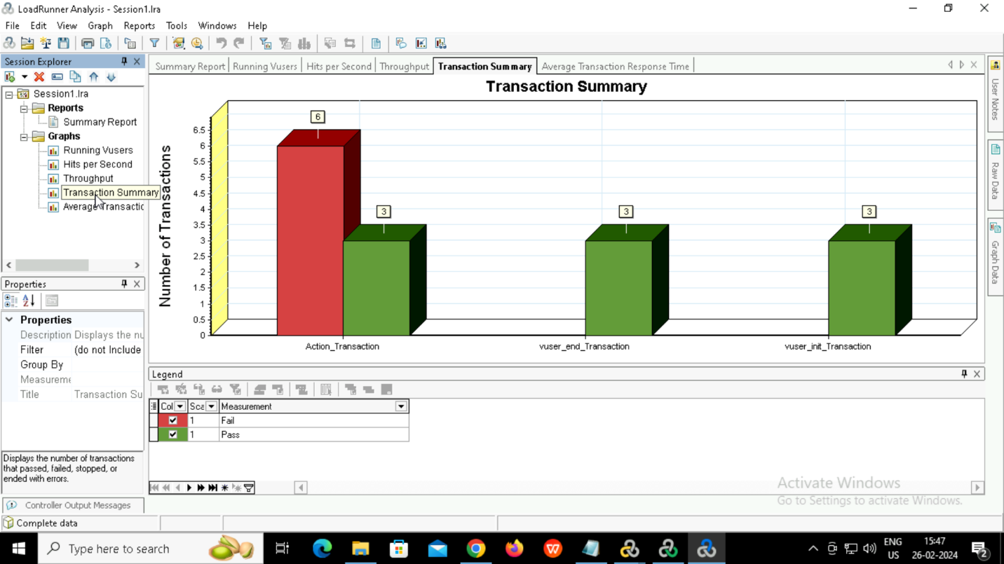

Average transaction response time

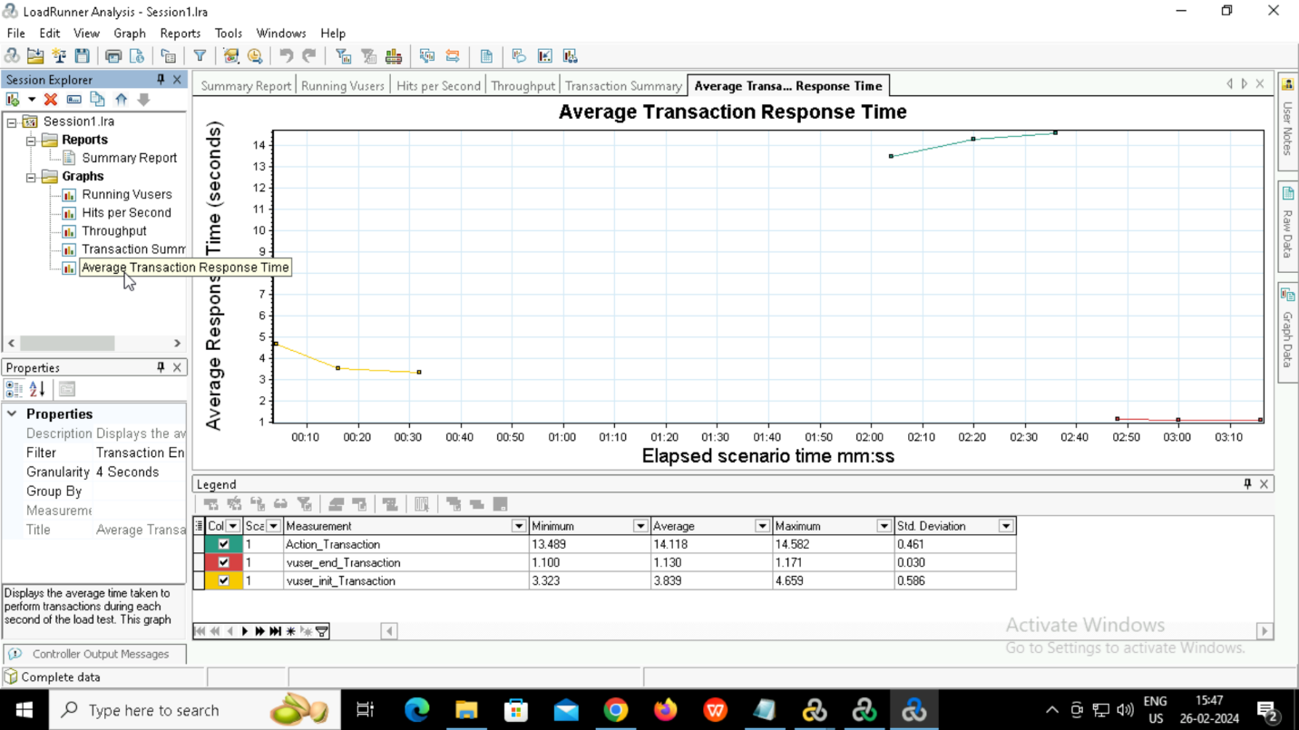

Generating HTML report.

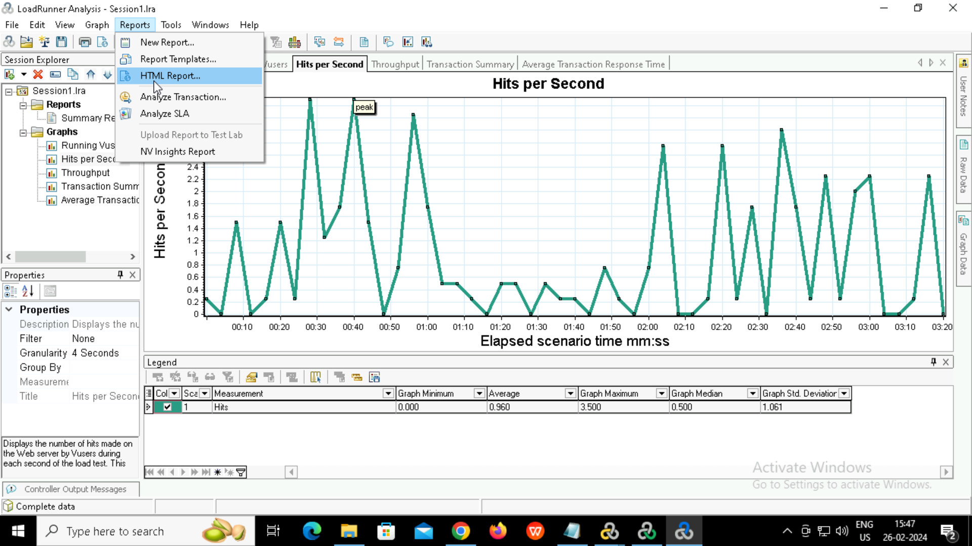

HTML Report

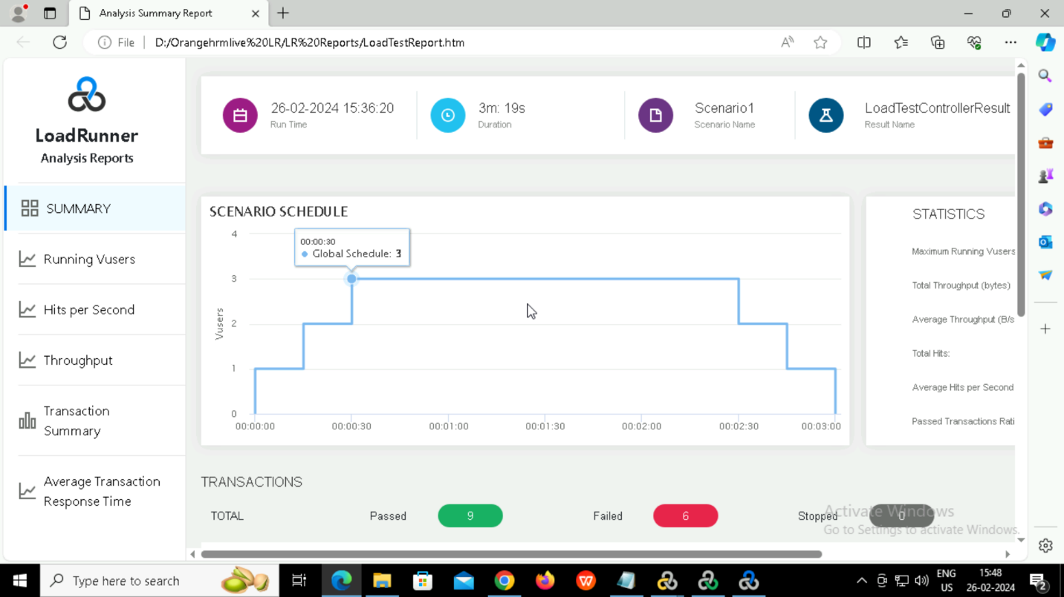

**(b)Stress Test**

**1.Virtual user generator**

Similarly for stress test also created a script and recorded and replayed

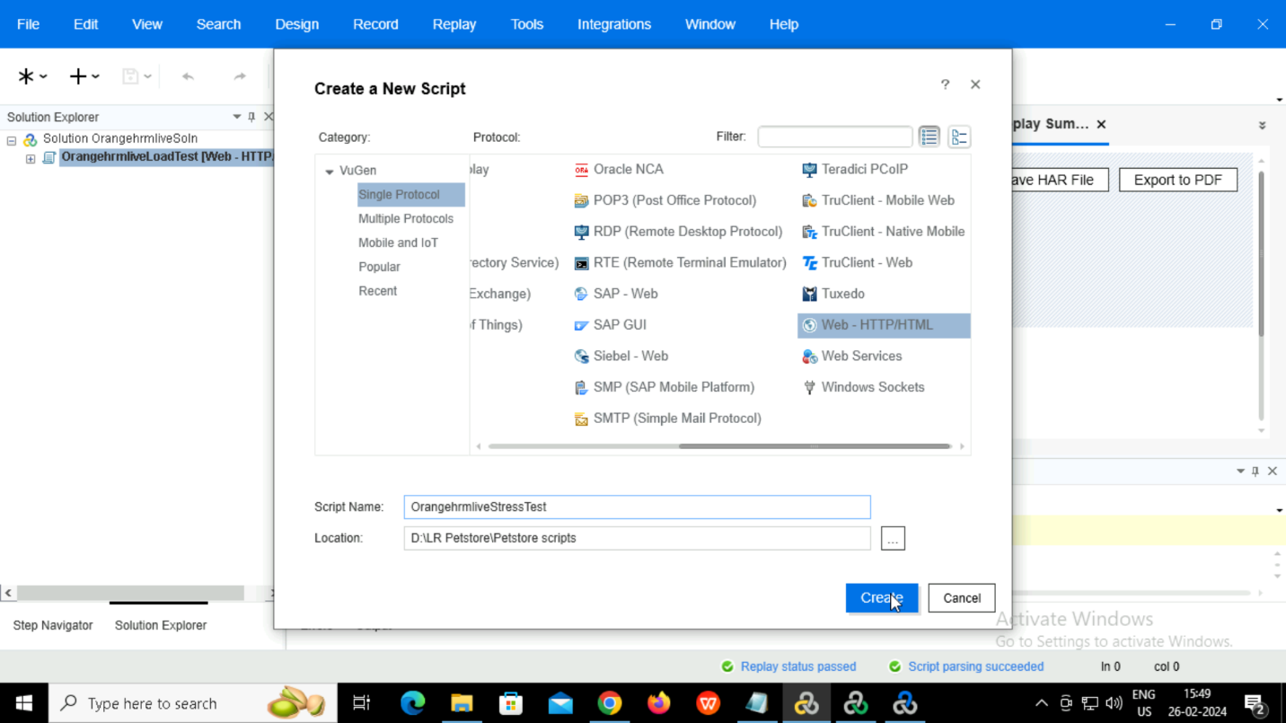

Set number of iterations

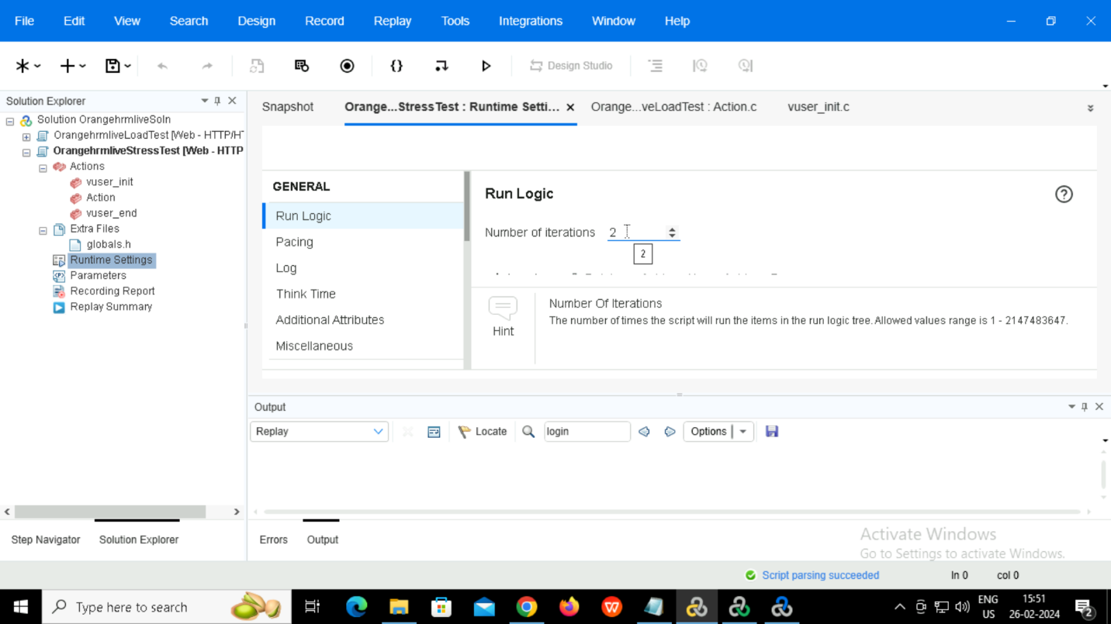

Code generated

Vuser_init

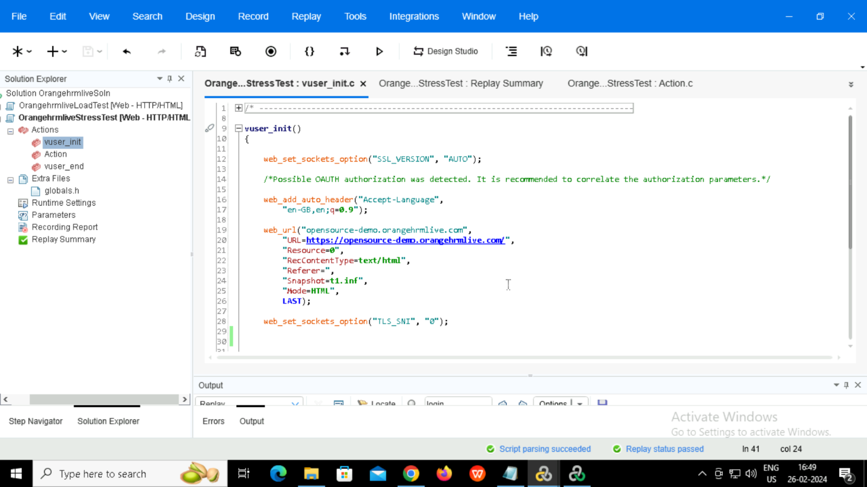

Action

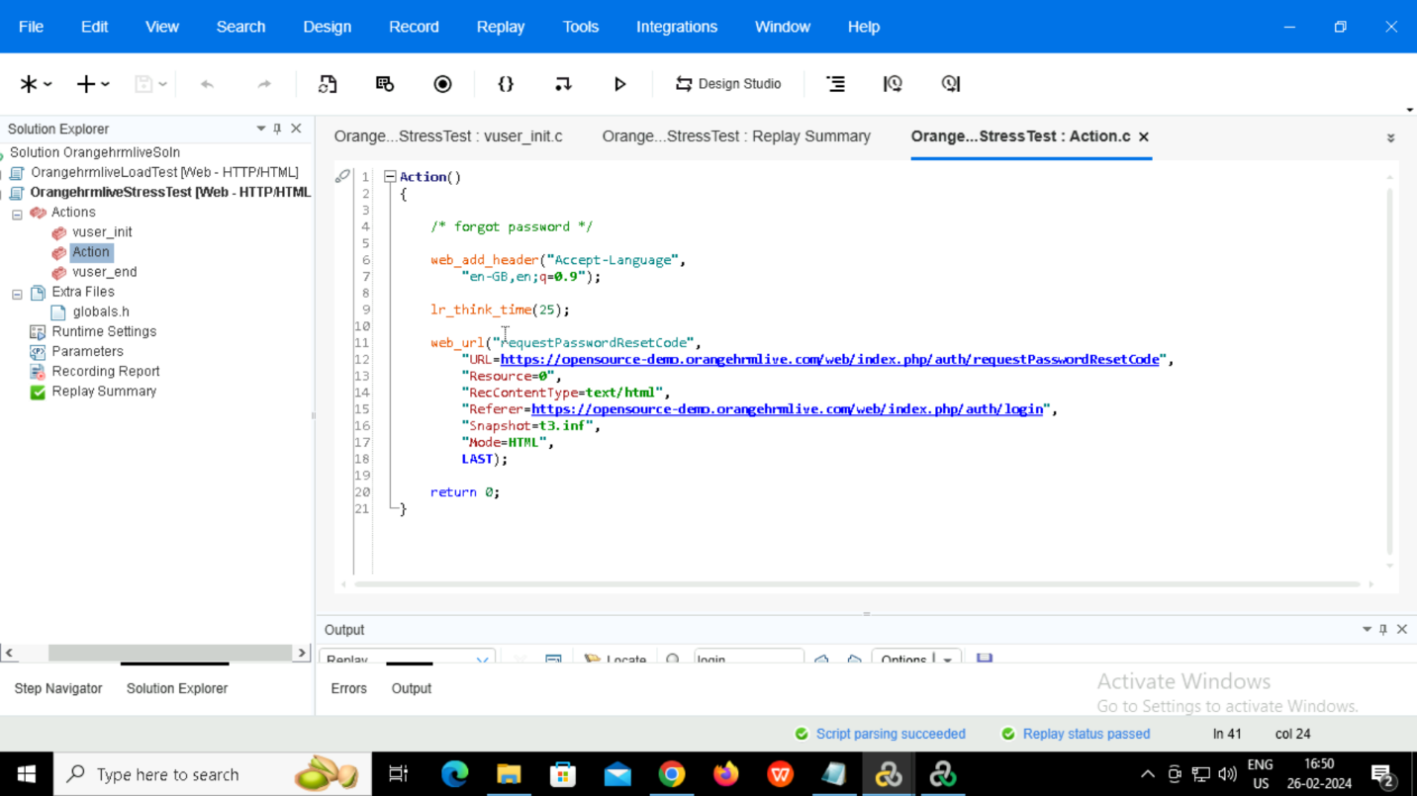

Script replay passed.

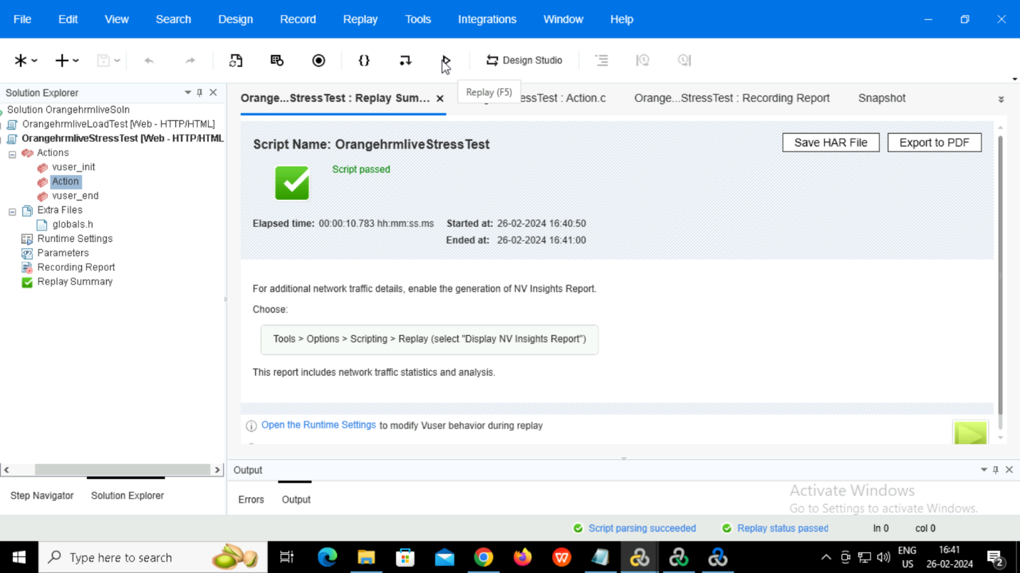

**2.Controller**

Adding script

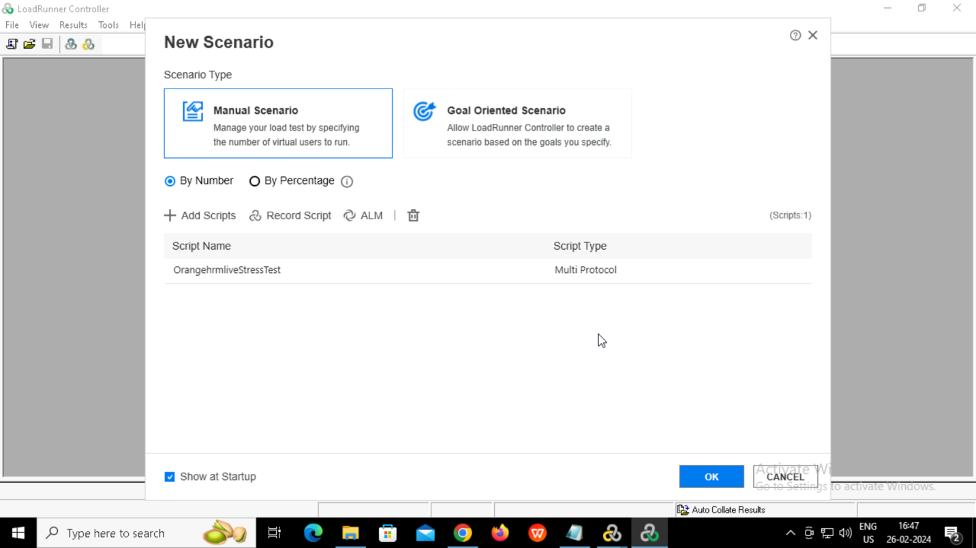

Adding 2

vusers

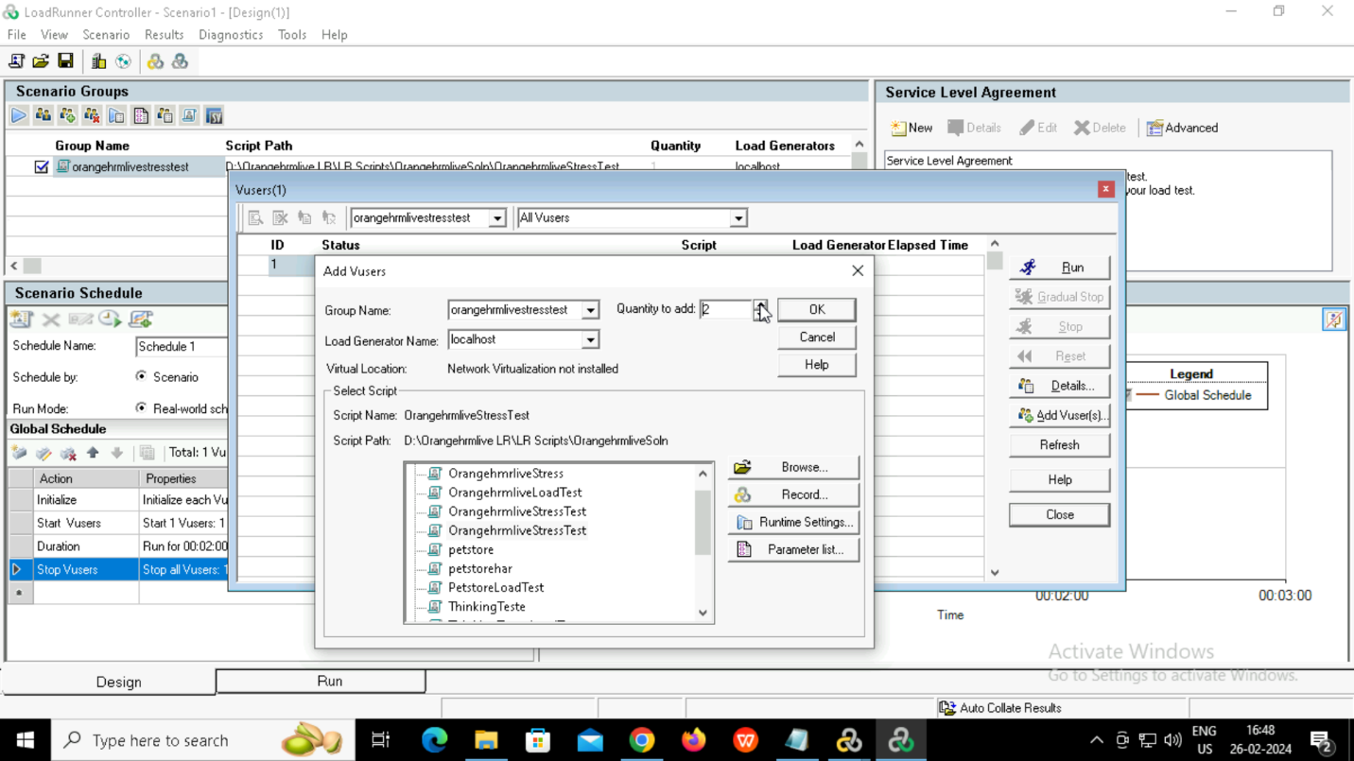

Setting stop vusers as 15 seconds.

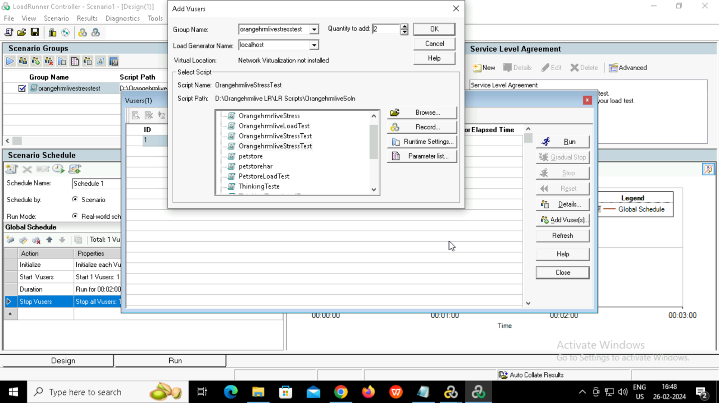

Starting the scenario and selecting the graphs.

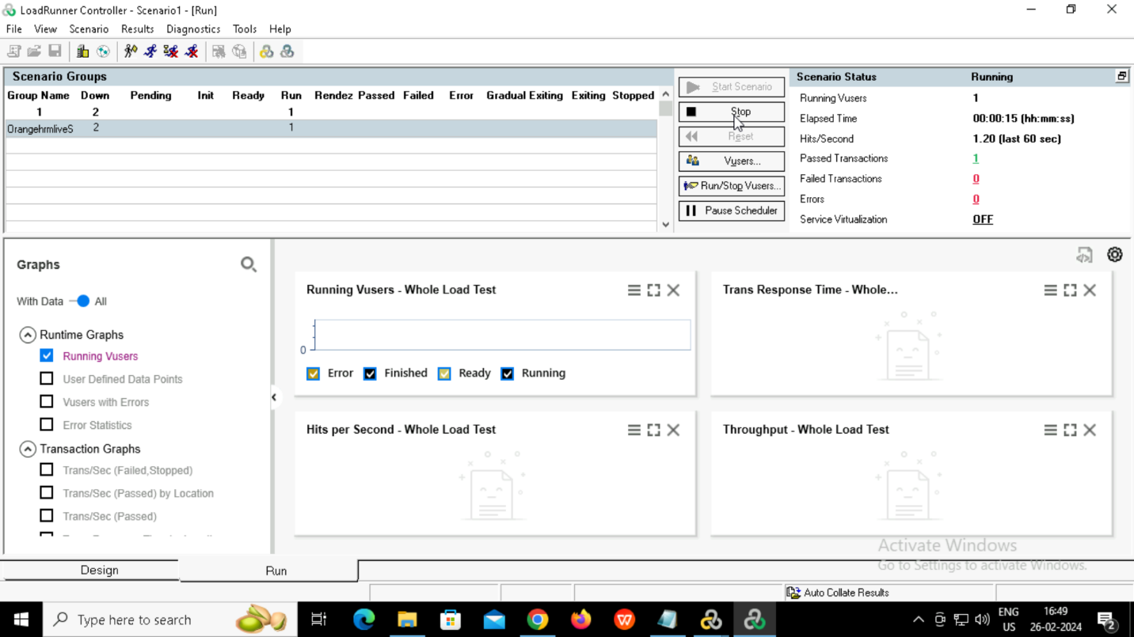

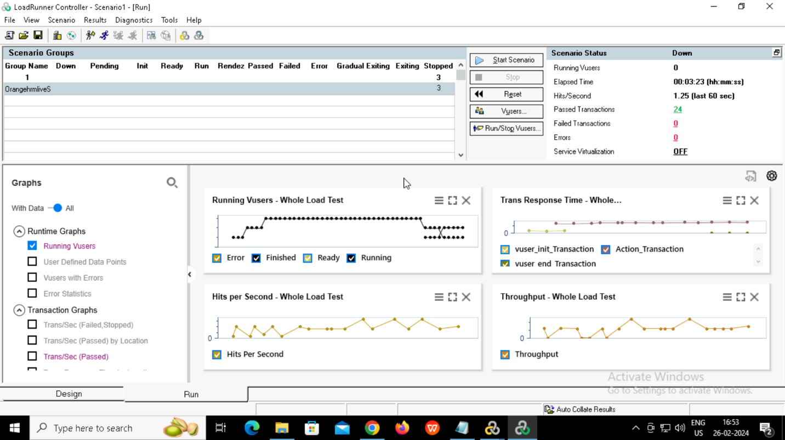

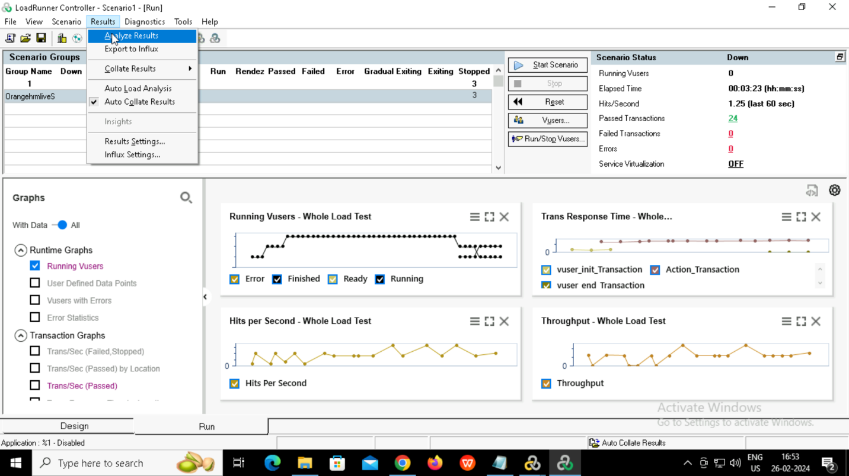

**3.Analyzer**

Summary report

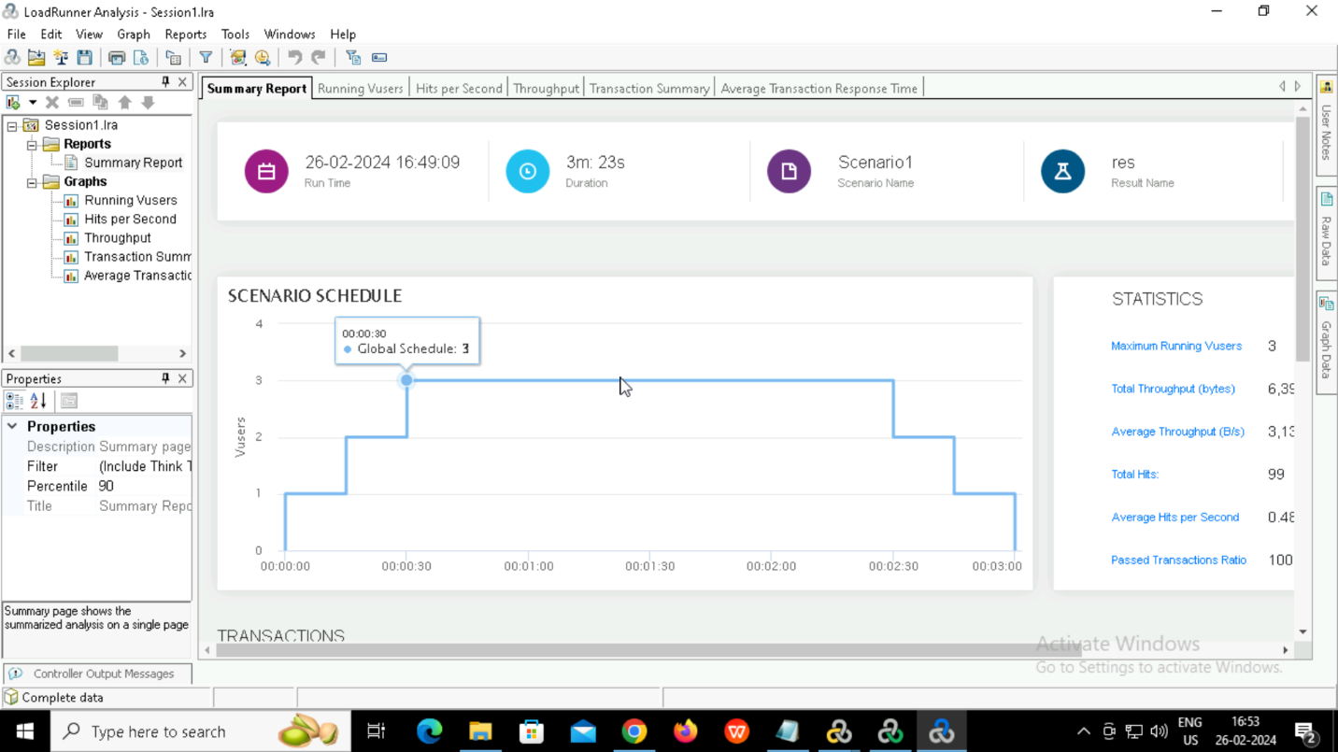

Average transaction response time

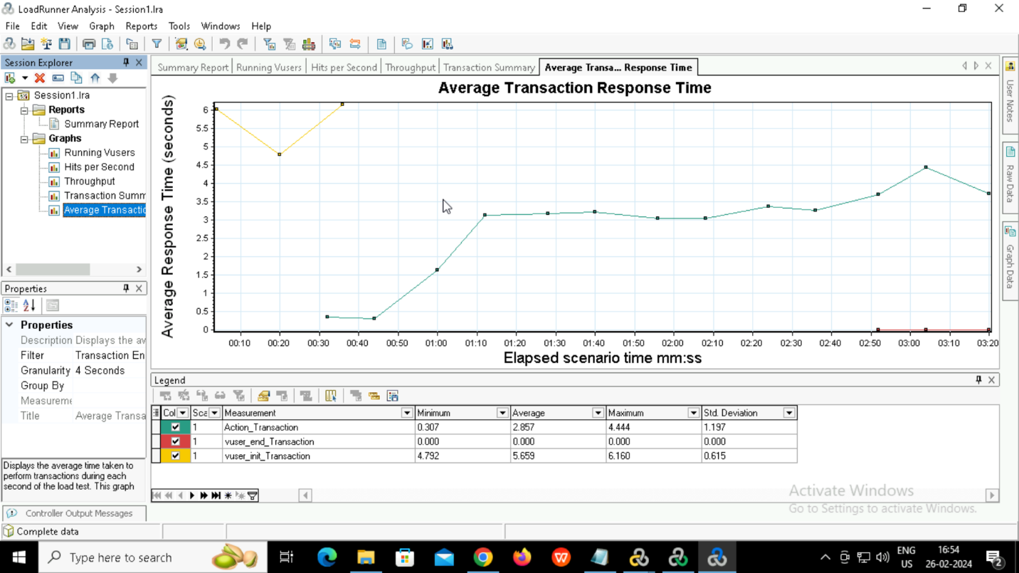

Transaction summary

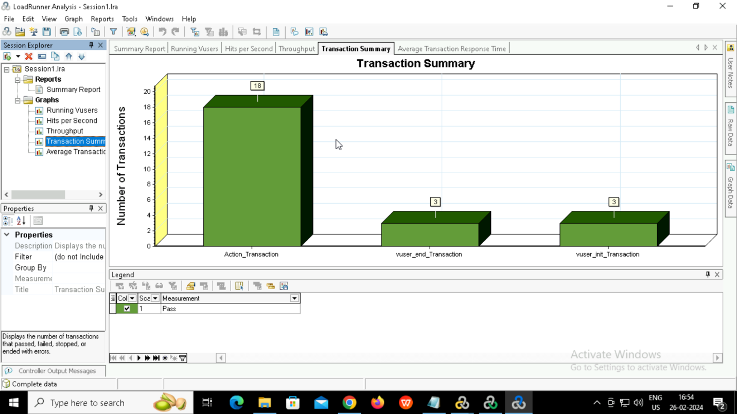

Throughput

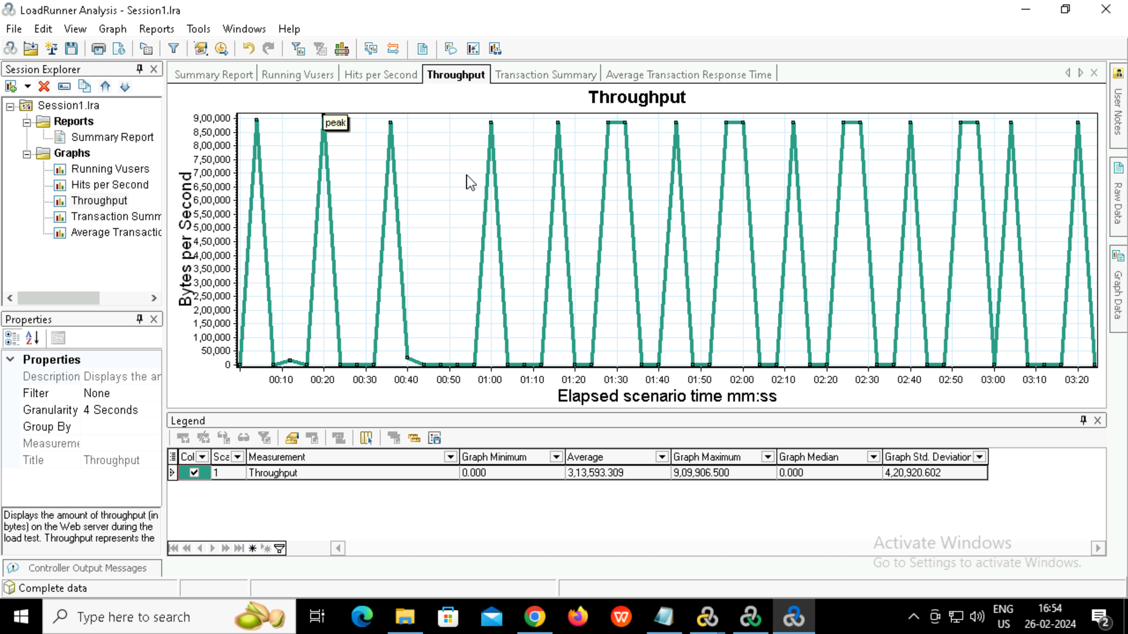

Hits per second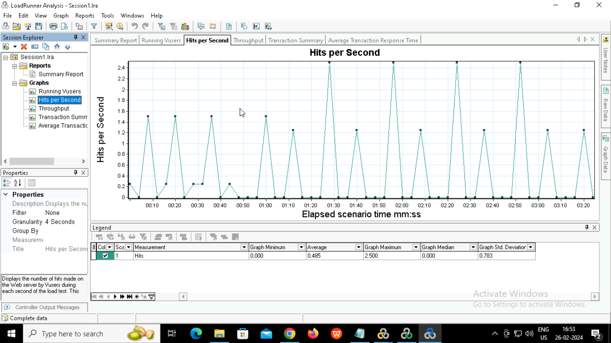

Running vusers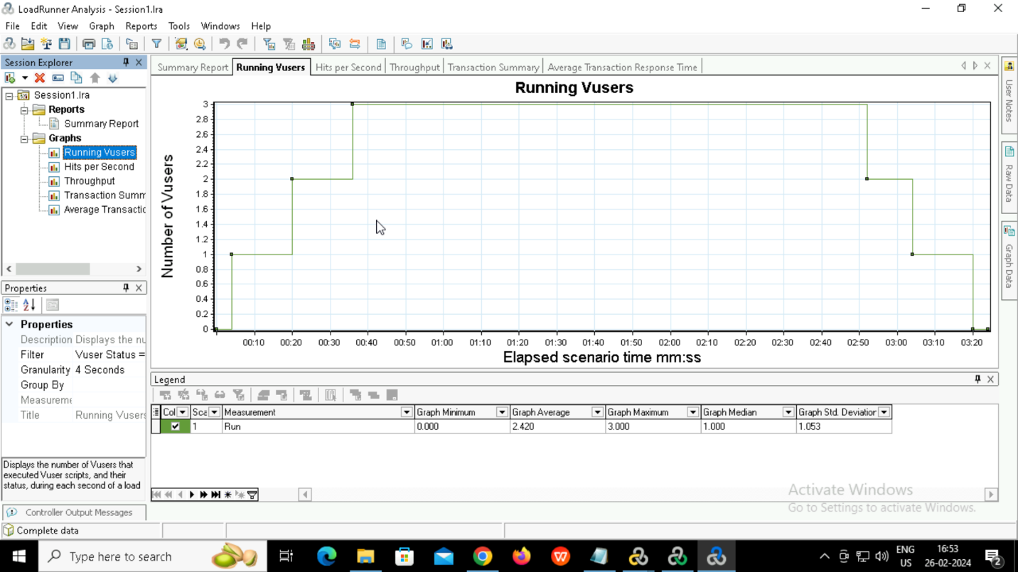

Average transaction response time

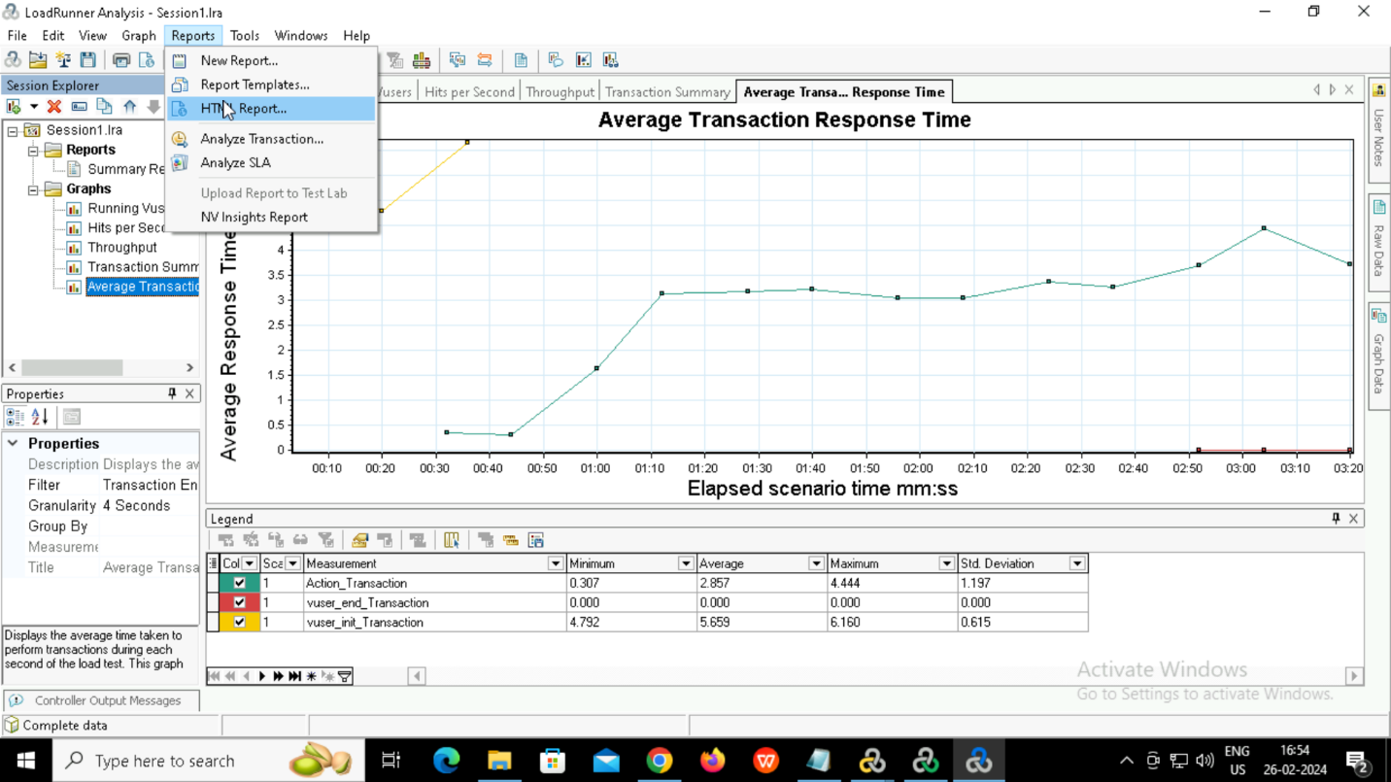

Generating HTML report

